Name:_________________________________


9-2 Solving Quadratic Equations by Graphing PRACTICE

Solve each equation by graphing.
1. $x^{2}$ – 2x + 3 = 0 2. $c^{2}$ + 6c + 8 = 0
Follow this QR code for videos on how to perform each one of these problems.
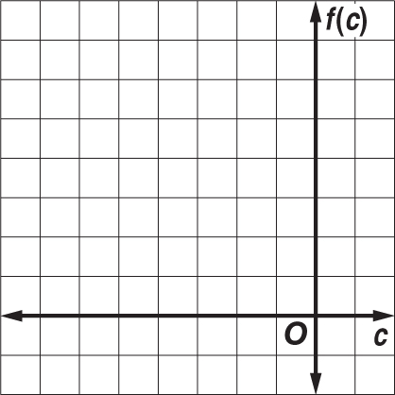
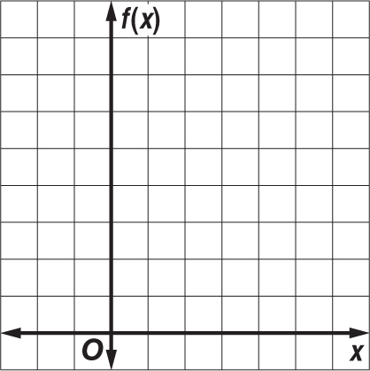

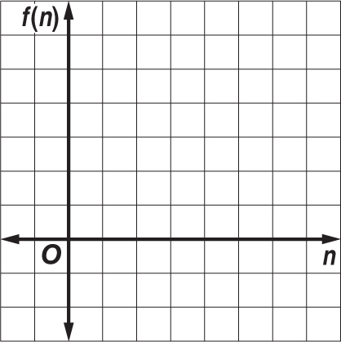
3. $a^{2}$ – 2a = –1 4. $n^{2}$ – 7n = –10
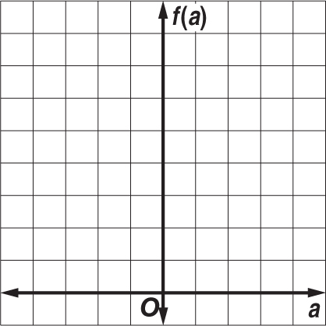

Solve each equation by graphing. If integral roots cannot be found, estimate the roots to the nearest tenth.
5. $p^{2}$ + 4p + 2 = 0 6. $x^{2}$ + x – 3 = 0
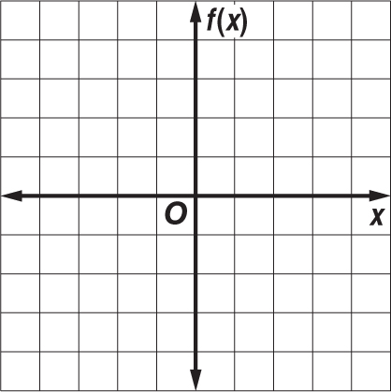
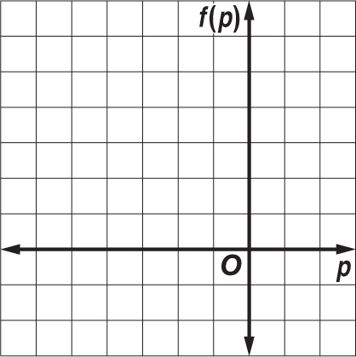

7. $d^{2}$ + 6d = –3 8. $h^{2}$ + 1 = 4h
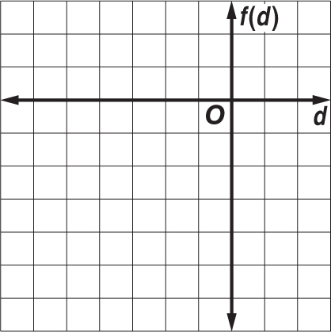

Name:_________________________________

9-2 Solving Quadratic Equations by Graphing HOMEWORK
Solve each equation by graphing.
1. $x^{2}$ – 5x + 6 = 0 2. $w^{2}$ + 6w + 9 = 0 3. $b^{2}$ – 3b + 4 = 0
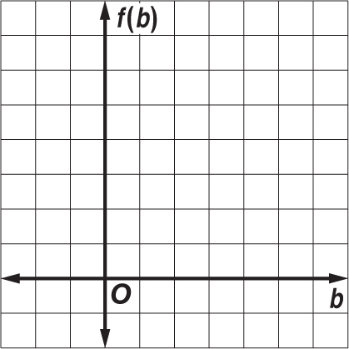
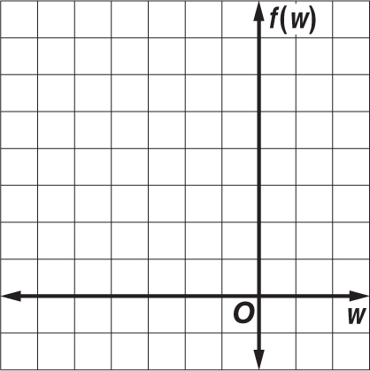
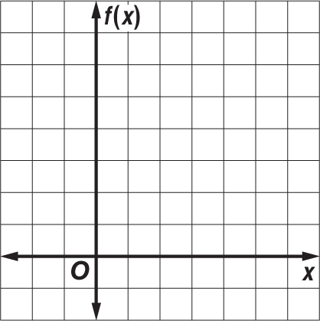

Solve each equation by graphing. If integral roots cannot be found, estimate the roots to the nearest tenth.
4. $p^{2}$ + 4p = 3 5. 2$m^{2}$ + 5 = 10m 6. 2$v^{2}$ + 8v = –7
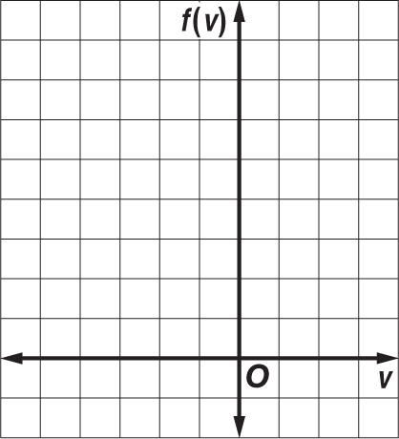
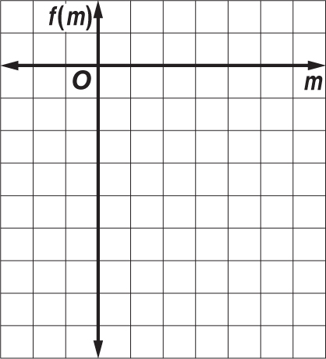
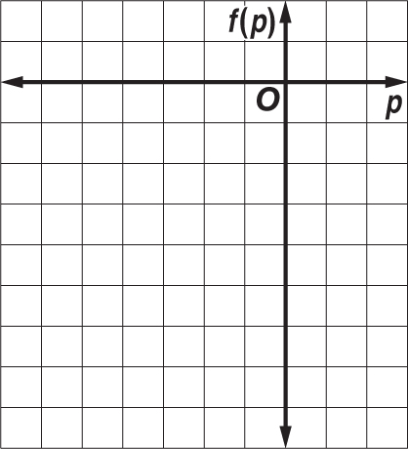

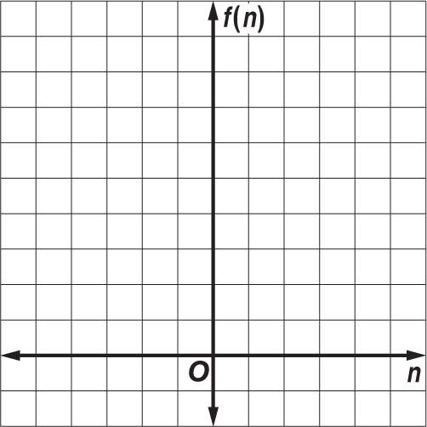
7. NUMBER THEORY Two numbers have a sum of 2 and a product of –8. The quadratic equation –$n^{2}$ + 2n + 8 = 0 can be used to determine the two numbers.

a. Graph the related function f(n) = –$n^{2}$ + 2n + 8 and determine its
x-intercepts.

b. What are the two numbers?

