Carbon
What is Carbon? | An ______________that bonds with other elements to form compounds.  Organic compounds:  ________________________________________  Inorganic compounds:  ______________________________________
Carbon cannot be ________________ or ____________________ on the earth.

The same carbon atoms are used repeatedly on earth by _____________________.

Where is Carbon? | Carbon atoms _____________________ through living  organisms also known as the ____________________,  the earth’s waters also known as the _______________,  the air, also known as the __________________, and  the crust of the planet, also known as the _____________.
Carbon Cycle: | The ________________ of carbon atoms through the 4 spheres of the earth’s system.

1. Carbon moves from atmosphere to plants | Plants pull _________from the atmosphere and use it to  make ______________ –this process is called  ____________________________  The carbon becomes part of the plant (stored food).  Draw an arrow to show the direction carbon is moving in this photo.
2. Carbon moves from plants to animals  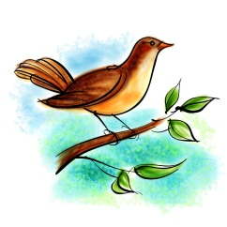 | the carbon that is in _____________  moves to the ____________________ that eat them.  Draw an arrow to show the direction carbon is moving in this photo
3. Carbon moves from animal to animal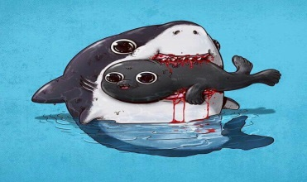 | Animals that eat other animals get the _______________  from the __________ of other animals they eat.  Draw an arrow to show the direction carbon is moving in this photo.
4. Carbon moves from plants and animals to the ground. 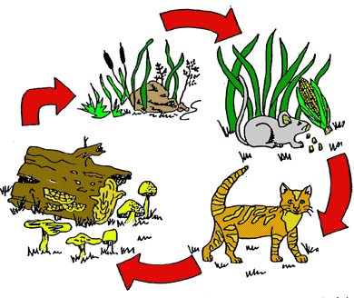 | When plants and animals die, their bodies are broken down  by organisms called __________________.  Decomposers return the carbon to the _______________.  Draw an arrow to show the direction carbon is moving in this photo.
5. Carbon moves from plants and animals to fossil fuels  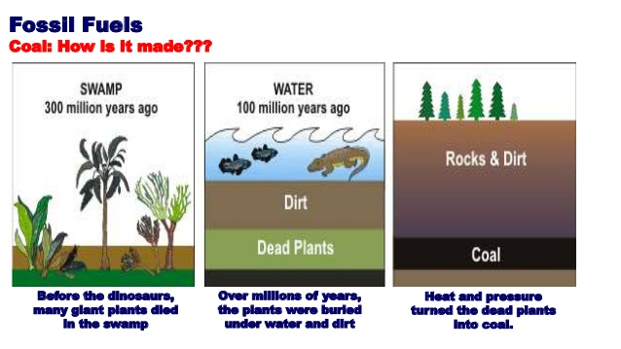 | Some plants and animals are not decomposed fully and become buried. After millions of years, the carbon ends  up in _________________________  ex.___________________________________________  Draw an arrow to show the direction carbon is moving in this photo.
6. Carbon moves from animals to the atmosphere.  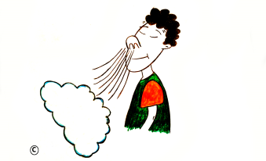 | Each time you exhale, you are releasing  ____________________into the atmosphere.  This carbon comes from the breakdown of ___________  through the process of ____________________________.  Draw an arrow to show the direction carbon is moving in this photo.
7. Carbon moves from the atmosphere to the ocean.  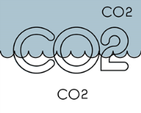 | The _____________, and other ____________________, soak up some carbon from the atmosphere.  Draw an arrow to show the direction carbon is moving in this photo.
8. Carbon moves from rocks to the ocean.  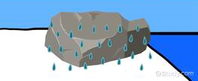 | When rocks ______________, they can add carbon to  surface water which eventually runs off to the ___________  Draw an arrow to show the direction carbon is moving in this photo.

Explain how the movement of carbon through the earth is the same as the flow of energy through the earth.

Explain how the movement of carbon through the earth is different than the flow of energy on earth.

