Name:______________________________
Cells 2
3 Main Parts of the Cell Label this cheek cell with the 3 main
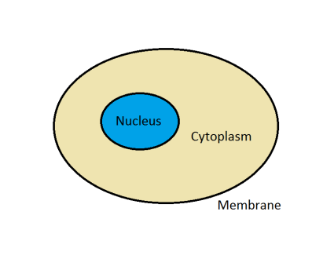
parts shown in the cartoon cell
1.___________: ________________________
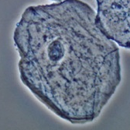
2.___________: ________________________

3.___________: ________________________

DNA | All the ______________ ______________ that tells a cell how to  ___________________ ________________
 | Found in the ______________ of every cell in your body
 | Your DNA came from your ___________ and _____________
Gene | Small part of the _______________
 | One specific ________________ for the cell
There is a gene for ___________________ and a gene for

____________________ and genes that can cause _______________
in your body.
Chromosome | A bunch of __________, twisted together inside the nucleus of a cell
 | Humans have _______ chromosomes in every cell
 | Chromosomes are found in ___________.
 | Mom passes ____________ the chromosomes in a special cell called an ______________.
 | Dad passes half of the chromosomes in a special cell called ______________.
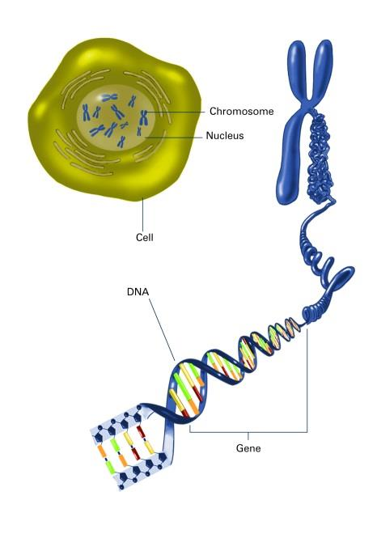
Label the picture: cell, chromosome, DNA, gene and nucleus

3
2
1

5
4

Cells must make new cells. The process of making new cells is called ____________ __________________.
Brainstorm: Think of 5 reasons why a cell would need to divide.

Cell division is necessary for:
S_____________:
G_____________:
R_____________:
R_____________:
R_____________: | Unicellular:
R_____________: | Multicellular:

In order for a cell to divide into a new cell that will function properly, the chromosomes (DNA) of the cell must be _______________________. The copying of the chromosomes (DNA) is known as ______________________.

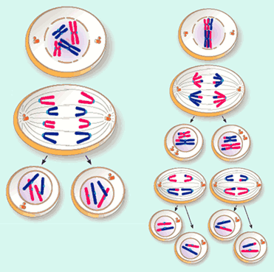

Picture A Picture B

