Name:____________________________________________

Modeling the Greenhouse Effect
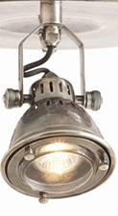
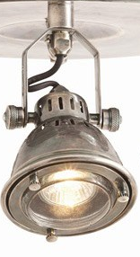

Predictions:
The temperature in Jar A will increase/decrease/stay the same because ________________________________
_____________________________________________________________________________________________
The temperature in Jar B will increase/decrease/stay the same because ________________________________
_____________________________________________________________________________________________
The temperature in Jar C will increase/decrease/stay the same because ________________________________
_____________________________________________________________________________________________
The temperature in the water of Jar C will increase/decrease/stay the same because _____________________
_____________________________________________________________________________________________
Prelab:
The picture above is the experiment we will be setting up. All jars will be exposed to bright light! Answer the questions below based on the picture.
Experimenting with jars A and B:
- What is the independent variable?
- What is the dependent variable?
Experimenting with jars B and C:
- What is the independent variable?
- What is the dependent variable?
Using your notes from 5.1, fill in the chart below showing the connections between this model of the greenhouse effect and the actual greenhouse effect taking place in the biosphere.
Part of Model | Part of the Earth | Connection  (Why?)
Jar
Cover
Light
Water
Air within Jar

Begin the Experiment
Location | Temperature
Time (min) | 0 | 5 | 10 | 15 | 20 | 25 | 30
Jar A

Jar B

Jar C

Water Jar C

Graph the temperatures for each jar on your graph paper. You will have 4 lines on one graph when you are finished. Be sure to make a key.

Answer the following questions.
- What was the difference in temperature from beginning to end for jar A?

- On the picture at the beginning of this lab, draw an arrow showing the movement of the light and transformation into heat in model A.
- Describe how model A is different than the actual earth as discussed in notes.

- What was the difference in temperature from beginning to end for jar B?

- On the picture at the beginning of this lab, draw an arrow showing the movement of the light and transformation into heat in model B.
- Describe how model B is similar to the actual earth as discussed in notes.

- Which jar showed the greatest difference in temperature change? A or B Explain why this jar had the largest change.

- What was the difference in temperature from beginning to end for jar C? for the water in jar C?

- What does the water represent?

- On the picture at the beginning of this lab, draw an arrow showing the movement of the light and transformation into heat in model C. Be sure to show this for the water and the jar.
- Explain the difference in temperature for the water in jar C and the air in jar B? Why would this occur.

- What questions (give 2) do you have about this topic now that the lab is complete?

