Name:______________________________
Class Notes Date: ________________
Text 3.1 p65-67
Main Ideas | Details | Your words
Studying Our Living Planet
Biosphere |  | Name 2 things from your life that are interdependent.  Name something in your life that is dynamic.  How are human economics and ecology linked?
Ecology

Interdependence

Dynamic

Economics

Figure 3.1 Levels of Organization
Species

Population

Community

Ecosystem

Biome

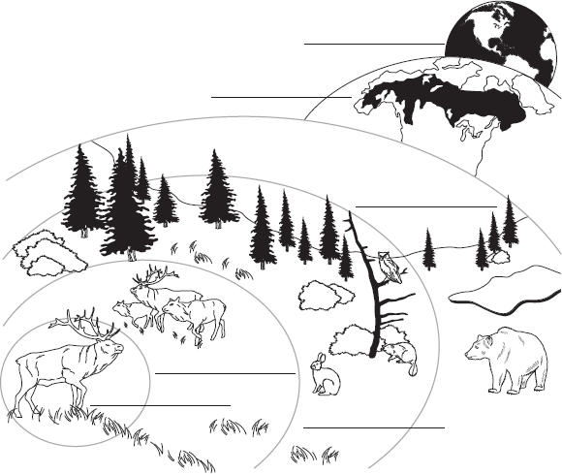
Label the levels
of organization on
the diagram.

Biotic and Abiotic Factors
Bio- means
Biology

Environment

Biotic |  | How are abiotic and biotic factors related to the environment?
Abiotic

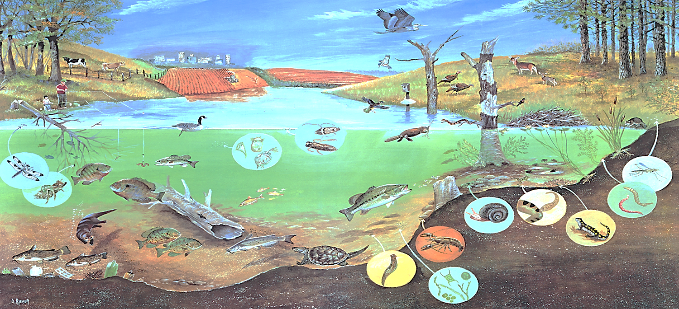

Use the picture above to name as many factors as you can. If the picture is unclear, try your best to guess what is being shown.

Abiotic Factors

(at least 6)

Biotic Factors

(at least 6)

