Name:______________________________
Class Notes Date: ________________
Text 3.1 p65-67
Main Ideas | Details | Your words
Studying Our Living Planet
Biosphere | Parts of the earth where life exists | Name 2 things from your life that are interdependent.  Name something in your life that is dynamic.  How are human economics and ecology linked?
Ecology | Interactions between living things and their environment
Interdependence | Relationship between 2 things that depend on each other
Dynamic | ever-changing
Economics | Goods and services for money
Figure 3.1 Levels of Organization
Species | Group of similar organisms that can produce fertile offspring
Population | Group of the same species in the same area  Ex. All of the coyotes living in Oswego, Illinois in the fall of 2019
Community | Different populations in a specific area  Ex. All of the coyotes, rabbits, squirrels, spiders and dandelions living in Oswego, IL in the fall of 2019
Ecosystem | All the organisms and their environment living together  Ex. All of the coyotes, rabbits, squirrels, spiders dandelions plus the temperature, amount of sunlight, oxygen levels and rainfall.
Biome | Group of ecosystems with similar features  Ex. Rainforests (similar amount of sunlight, rainfall, plants and animals no matter where they are found)
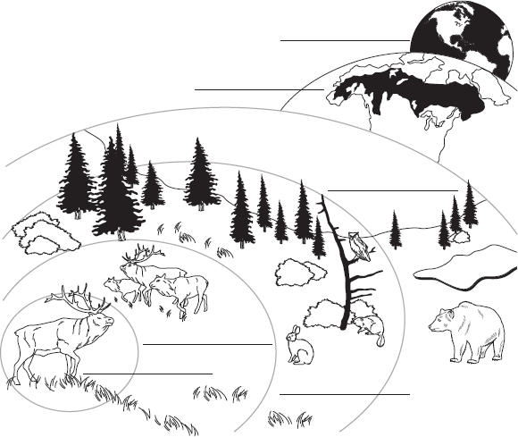
biosphere
Label the levels
of organization on biome
the diagram.

ecosystem

population

species

community

Biotic and Abiotic Factors
Bio- means | life
Biology | Study of life
Environment | All of the factors and conditions surrounding living things  Ex. Mountains, climate, soil types, clouds, oxygen levels
Biotic | Living things | How are abiotic and biotic factors related to the environment?
Abiotic | Nonliving things
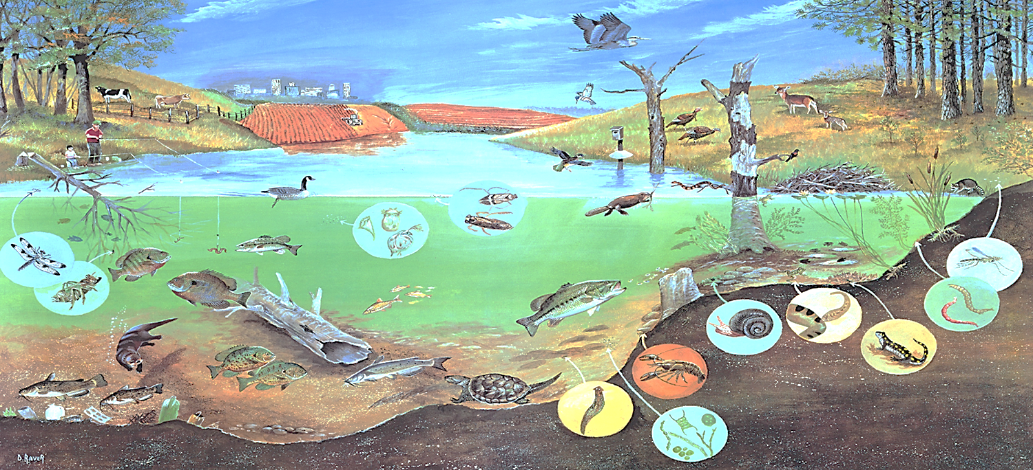

Use the picture above to name as many factors as you can. If the picture is unclear, try your best to guess what is being shown.

Abiotic Factors  (at least 6) | Water, soil, air, rocks, sand, pollution from factories or city in background, fertilizer from farm, garbage on the bottom of the pond, bird houses, fishing pole, water temperature, air temperature, amount of oxygen in the water, clouds, light
Biotic Factors  (at least 6) | Fish, trees, crops, people, deer, birds, crayfish, frogs, salamander, snail, unicellular pond animals, cow, insects

