100 years later, remembering the crucible called World War I

Henry Chu Copyright © 2017, Los Angeles Times
The shot that changed the world rang out on a sunny summer's morning in Southeastern Europe. No one knew then that the assassin's bullet would spell the death not just of an Austrian aristocrat but the entire global order, with four empires and millions of lives lost in a conflict on a scale never before seen.
Exactly 100 years ago Saturday, Franz Ferdinand, heir to the throne of the Austro-Hungarian empire, and his wife, Sophie, were shot at close range by a young Serbian nationalist on the streets of Sarajevo.The assassination set off a chain reaction that, barely a month later, culminated in a continent at war.
What many thought would be a brief, even heroic, conflict metastasized into a four-year nightmare that engulfed dozens more nations, including the United States, redrew the map of Europe and introduced the world to new horrors such as chemical weapons and shell shock. A second, even deadlier global catastrophe, which had its seeds in the first, struck within a generation.
For many modern-day Europeans, the conflict is emblematic of the madness of war. In such a cataclysm there are no winners, many say, and it's fruitless to seek logic, meaning or justification in soldiers asphyxiating in gas attacks, or waves of men charging over the tops of trenches only to be mowed down by machine-gun fire within seconds.
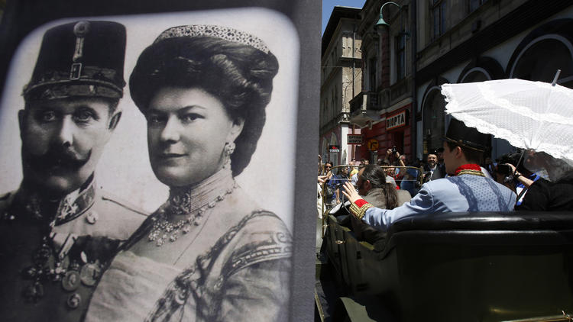
On June 28, 1914, Gavrilo Princip assassinated Archduke Franz Ferdinand of Austria, heir to the Austro-Hungarian throne, and his wife, Sophie. The assassination is regarded to have triggered the beginning of World War I.
This week, European leaders gathered to remember those sacrifices at a solemn ceremony in Ypres, Belgium, where countless soldiers fell on the muddy fields of Flanders. "This commemoration is not about the end of the war or any battle or victory," said Herman Van Rompuy, a former Belgian prime minister. "It is about how it could start, about the mindless march to the abyss, about the sleepwalking — above all, about the millions who were killed on all sides, on all fronts." Van Rompuy is now president of the council of the 28-nation European Union, an expression of regional comity and solidarity that could scarcely have been imagined 100 years ago.
The union is far from perfect: Leaders bickered publicly this week over who ought to be handed one of the EU's plum jobs, and recent elections to the European Parliament produced a crop of winners from parties avowedly hostile to further integration. But in 2012, the EU was awarded the Nobel Peace Prize in recognition of how far Europe has put its blood-soaked past behind it.
In another sign of healing divisions, French President Francois Hollande will dedicate a memorial in November inscribed with the names of all 600,000 troops who perished in northern France during World War I, regardless of which side they fought on.
That seems to mirror a new tendency to gloss over the question of who was to blame for the war — many label Germany the chief aggressor — and focus instead on what happened, said Annika Mombauer, a historian at Britain's Open University. Such an approach sits uneasily with her. "Given the countless victims the war claimed, the unimaginable horrors that were inflicted all over the world, it is fair and justified to pose the question of who was ultimately responsible for this," she said. "Of course, we have not managed to agree on an answer in a hundred years, and doubtless we never will.
"The crisis of 1914 shows us that it is dangerous to be too complacent, to assume that bluff will work and that the other side will not ultimately be prepared to go to war," Mombauer said. "The decision-makers of Austria-Hungary and Germany deliberately took the risk that the crisis they provoked might escalate into a full-scale war. The other governments were prepared to call their bluff."
The Great War also underscored the rise of the United States and the dawn of an American century. The principle of self-determination of nations took root, which continues to be tested. Three months from now, Scotland will vote on independence from Britain; Catalonia seeks a similar referendum on secession from Spain.
The idea of bringing nations together in an international talking-shop aimed at keeping the peace also crystallized in the ashes of World War I.
In some ways, the Great War was a family affair: King George V of Britain, Kaiser Wilhelm II of Germany and Czar Nicholas II of Russia were cousins. The war swept away most of those dynasties. The Russian Revolution ushered in the world's first communist state; a defeated Germany witnessed the birth of the Weimar Republic. The Ottoman Empire was broken into pieces, and the map of the Middle East was redrawn as well.
Islamic militants this month tore down border posts along the frontier between Iraq and Syria, a line drawn after the Turkish empire was dismembered. The central question for Iraqis is whether their country, defined by those borders, can survive.
Across Europe, not just the political but the old social older crumbled as a result of World War I."The Great War … was a rupture," Van Rompuy said. "This is the end of yesterday's world, the end of empires, aristocracies and also an innocent belief in progress."
Nenad Prokic, a Serbian playwright and former lawmaker, struggles to make sense of the conflict a century after his compatriot, 19-year-old Gavrilo Princip, angry about Austria's annexation of Bosnia-Herzegovina, gunned down Franz Ferdinand. A month after the assassination, Austria-Hungary retaliated, its ally Germany moved on France, Russia and Britain mobilized their forces, and within a week, all had formally declared war.
The repercussions were enormous on Prokic's country, which lost a quarter of its people, including more than half its male population. "We could not recover from that," he said. The nation of Yugoslavia, and a fragile hope, emerged from the rubble. But that fell apart violently, too, in the Balkan wars of the 1990s, which gave the world the brutal euphemism of "ethnic cleansing." Serbia, an international pariah for years afterward, is hoping to rehabilitate its image and gain a foothold in the EU. "Now we are trying for a quarter of a century to organize a new state for us — very unsuccessfully, I must say," said Prokic, who lives in Belgrade.
In his new play, "Finger, Trigger, Bullet, Gun," Prokic explores the buildup to World War I and the "human stupidity" that tries to turn mass carnage into virtue. The drama premieres Saturday at the London International Festival of Theatre, which is devoting the entire weekend to works dealing with the war's enduring aftermath. Onstage will be more than 19,000 dominoes, for the number of British soldiers killed on the first day of the Battle of the Somme. At the close of the play — which ends in the present, with the characters discussing Europe and the crisis over Russia's seizure of Crimea this year — the dominoes will be toppled.
Naturally, the first domino represents Franz Ferdinand, whose death June 28, 1914, touched off the war that was supposed to end all wars. "One hundred years ago, the butchery began, and so many lives disappeared," Prokic said. "We must at least try for a moment to avoid such a big catastrophe in the future."

