Development Notes

Development implies “progress”
- Progress in what?
- Do all cultures view development the same way?
- Do all cultures “value” the same kinds of development?

Definition for Development.
- Making ______________________________________________________ ______________________________________.
- A process of ____________________________ in the material condition of people through the diffusion of knowledge and technology.
- The process of growth, expansion, or realization of potential; bringing regional resources into full _________________________________________.

Geographers are interested in the distribution of wealth in the world today.
- What are the ___________________________ of wealth worldwide?
- Why is _______________________ distributed in the manner that it is?
- What can be done to improve the wealth of the _________________________ countries?
- They explain how people in various places make a living by analyzing the characteristics of, differences among, and movements between areas of _____________________________________________________________________.

Characteristics of Development
What are the differences between education and the status of women in LDCs vs. MDCs?

___________________________________________________________________________________________________

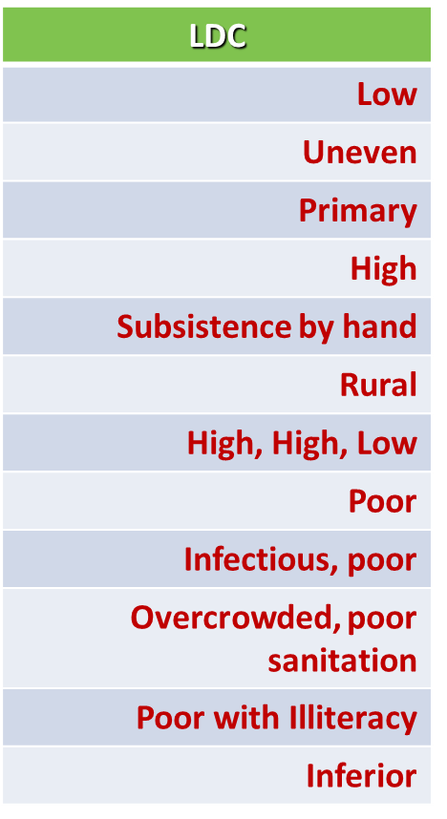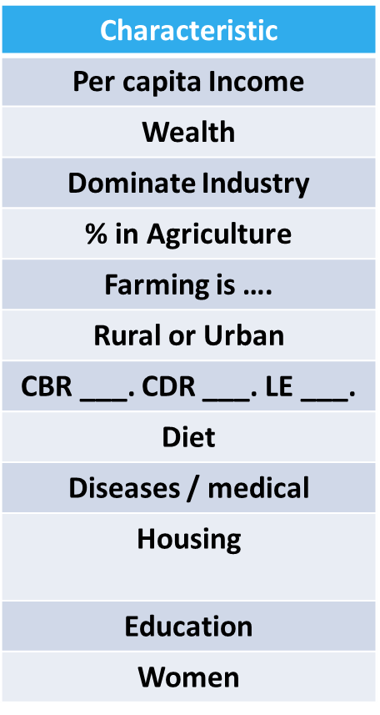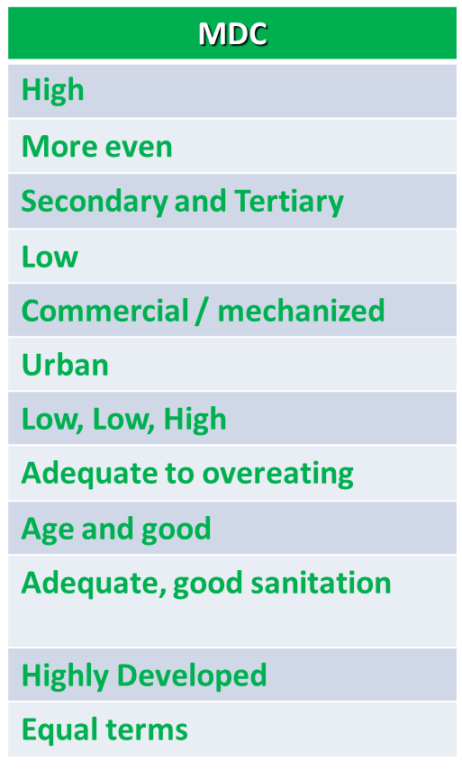
How do we describe the world?
An old Cold War way…
During the Cold War, how did we classify developed or developing nations?

How was a Communist nation classified?

What is the Better Way to Classify Countries? (5 Levels)

Introducing Development
Countries and regions are ___________________- by development
Human Development Index (HDI) measures development:
Decent __________________________________________________
Long and healthy life (LE)
Access to ________________________________________________

Standard of living in HDI:
__________________________________________________ (GNI) adjusted for purchasing power parity (PPP) per capita
* Other measures of standard of living:
- Primary, secondary, tertiary ________________________- structure
- __________________________________________

What is the difference between GNP and GDP and GNI?
GNP-

GDP-

GNI-

Define Purchasing Power Parity-

If Bermuda has the highest PPP, what does that mean about the wealth/income of its citizens?

Issues with Measuring Economic Development
All measurements count the:
____________________________________– the legal economy that governments tax and monitor.

All measurements do not count the:
____________________________________ – the illegal or uncounted economy that governments dont tax or keep track of.

Other Ways of Measuring Economic Development (Job Structure, Infrastructure)
Transportation and Communications
- _______________________________________________________________
Occupational Structure of the ____________________________________

What is being produced under each economic sector?
Primary-

Secondary-

Tertiary-

Quaternary –

Quinary –

Non-Economic Measures of Development
- Dependency Ratio
- Education:
  - LDC’s 2/3 illiterate, MDC’s 1% illiterate
- Public Services: access to safe drinking water
- Health Services: ratio of people to doctors
  - MDC 1:350, LDC 1:5,800, Sub Saharan 1:18,500
- Total Fertlility Rate
- Infant Mortality Rate
- Gender Inequality

- Dependency Ratio - A measure of the number of people under the age of ______ and over the age of ________ that depends on each working-age adult.

Access to knowledge in HDI:
- Years of school for ___________________. (25 yr. old)
- Expected years schooling for ____________________(5 yr. olds)
- Other measures of access to knowledge:
  - Pupil/teacher ratio
  - Literacy rate

Where Are Inequalities in Development Found?
- ____________________________ Inequality
- Gender Empowerment and ________________________________
- ______________________________Health
- HDI and Gender Inequality
- Unequal and Uneven Development in Countries

Gender-related Development Index (GDI):
- Same measures as HDI but by _______________________.
- Decent standard of living, long and healthy life (LE), access to knowledge

The GII is composed of measures of
- ________________________health, empowerment, and the ________________________ market.
- Larger numbers indicate _____________________________ gender inequality.
- The _____________________________ fertility (births per 1,000 women aged 15 to 19) rate is included in the GII.
- The _____________________________ mortality rate is included in the GII.
- Another measure of female empowerment is the ratio of girls to boys in ___________________school.
Countries with ratios above 1 have more girls than boys enrolled.
- One measure of female empowerment is the percentage of seats held by women in a country’s __________________________________________________________

Why is Energy Important for Development?
- Energy Demand and Supply
- _____________________________ is the quantity of something that producers have available for sale.
- _____________________________ is the quantity that consumers are willing and able to buy.
- 5/6 of the world’s energy needs are supplied by fossil fuels, which is an energy source formed from the residue of plants and animals buried millions of years ago.
  - Coal (27.9%)
  - Petroleum (33.2%)
  - Natural Gas (22.1%

Demand for Energy
- Although fewer in number, developed countries consume about______________ of the world’s energy.
- Percent of World Energy Consumed
- China: 20.4%
- U.S.: 18.3%
- Europe: 15.1%
* Per capita consumption of energy is greatest in __________________________________.
* Contains 1/20 of world’s population and consumes ____________________________of the world’s energy.
* Per capita consumption of energy is nearly three times greater in developed countries than in ________________________________________________________
Energy Supply - Earth’s energy resources are not distributed evenly.
- Global Coal Distribution
- Today’s main reserves of coal are located in the mid-latitude countries.
- China / U.S. supply nearly 1/2 and ¼, respectively, of the world’s coal.

- Global Petroleum Distribution
- Today’s main reserves are located on the ____________ and in areas once under water millions of years ago.
- __________________________________ together supply ¼ of the world’s petroleum supply.
- ______________________ supplies ¼ of the global supply
- Remaining ½ of world supply of petroleum is supplied by developing countries (primarily in S.W. and Central Asia)

- Global Natural Gas Distribution
- 1/3 of natural gas production is supplied by ________________________________
- 1/3 by developing regions
- 1/3 by developed countries (primarily the __________________)

Energy Reserves
Two types of energy reserves exist.
- __________________________________ - A supply of energy remaining in deposits that have been discovered.
- __________________________________ - A supply of energy that is undiscovered but thought to exist.

Proven Reserves - Remaining supply of fossil fuels at current demand
Coal: ________ years
Natural Gas: ____ years
Petroleum: _______ years

Controlling Petroleum Reserves
- Organization of the Petroleum Exporting Countries (OPEC) formed in 1960 to gain more control over their resource, as a result of U.S. and European transnational companies exploring and exploiting the oil fields of developing countries.
- Members - Southwest Asia and North Africa
    - Algeria, Iraq, Kuwait, Libya, Qatar, Saudi Arabia, and United Arab Emirates
  - Other Regions
    - Angola, Ecuador, Iran, Nigeria, and Venezuela
- Under OPEC, prices set by governments possessing the oil reserves rather than by petroleum companies.

Alternative Energy Sources

Nuclear Energy
- Electricity produced by splitting uranium atoms in a controlled environment via a process called fission.
- Nuclear Energy Distribution
- Supplies ______________ of world’s electricity
- Used by only __________________ of world’s nearly 200 countries
- 19 developed countries; 11 developing countries
- 2/3 of world’s nuclear power generated in ________________________________________
- Most highly dependent countries clustered in Europe
- Relatively higher concentration of nuclear power plants in the ___________________ half of the U.S.

Nuclear Energy Challenges
- ___________________________________ is highly lethal to humans.
- Not possible to burn or chemically treat such waste to make it safe for human exposure.
- Waste must remain isolated from human contact for ____________________________, until it loses radioactivity.
- Uranium is a nonrenewable resource
  - Proven reserves projected to last _____________________ years at current consumption rate.
- High Cost
  - Nuclear power plants cost several billion dollars to build.
  - Complexities of ____________________________________________________ of radioactive waste are costly.

Hydroelectric Power
- Harnesses the power of moving water to convert it to electricity.
- Leading source of renewable energy in both developed & developing regions.
- _______________________ most popular source of electricity after coal
- Lack of remaining acceptable sites to construct a hydroelectric dam poses a challenge to increasing reliance in U.S.

Biomass
- Biomass energy sources include ______________________ that can be burned as fuel to generate electricity and heat.
  - Sugarcane, corn & soybeans can be processed into motor-vehicle fuels

Wind Energy
- Relatively minimal impact on the __________________________
- Greater potential for increased use, because only a small portion of the potential resource has been harnessed.
- Greatest challenge for expanding reliance is opposition by environmentalists who voice their concerns about windmills being ____________, lethal for birds and bats, and a visual blight on the ____________________

Solar Energy
* Ultimate renewable resource supplied by the Sun.
* U.S. receives _____________ of its electricity from solar, but potential growth is limitless.
* Solar energy is harness through one of two means.
- Passive solar energy systems capture energy without using special devices.
- Active solar energy systems collect solar energy & convert it either to heat energy or to electricity either directly
or indirectly.

Development Theories

Two Paths to Development
Developing countries chose one of two models to promote development:
- Self-sufficiency
- Countries encourage ___________________________ production of goods, discourage ___________________ ownership of businesses and resources, and protect their businesses form _________________________________.
- Most popular for most of 20th century

- International trade
- Countries open themselves to ________________________________-_ and international markets.
- Became more popular beginning in the late 20th century

Self-Sufficiency Path Key Elements
- Barriers limit the __________________________ from other places and protects domestic products.
- Businesses are not forced to compete with ________________________________________________.
- Investment spread almost equally across all _______________________sectors and in all regions of a country.
- Minimalized discrepancies in wages among urban and rural dwellers with the intent to reduce poverty.

Self-Sufficiency Challenges
- Protection of ______________________________________
- Guaranteed high prices made possible by isolation from international competition creates _______________________________- for business to improve quality of product or become more efficient.
- Companies protected from international competition aren’t compelled to keep up with rapid technological changes.
- Need for ________________________________-
- A complex administrative systems needed to administer the controls encourages inefficiency, abuse, and corruption (__________________________)

International Trade
- Sell what you have on the _________________________________!
- Take that $$$ and finance in other areas of development.
- Examples?
- Four Asian Tigers
  - (SK, S, T, HK)
  - What did they sell?

- Arabian Peninsula
- What did they sell?

International Trade Challenges
1. ____________________________________________________________
Commodity prices are not guaranteed to rise faster than the cost of products a developing country needs to purchase.
2. ________________________________________________________________________
Developing countries may allocate all resources to few take off industries instead of spreading resources among the other companies that provide food, clothing, and other necessities for local residents.
3. ____________________________________-
Developing countries have found increased difficulty selling their manufactured goods in a world market that has recently declined for many products.

International Trade Approach Triumphs
- Most ________________________ have embraced the international trade approach since the late 20th century.
- Trade has increased more rapidly than wealth as measured by _______________.
- Optimism about the benefits of this development model based on three observations:
- If existing developed countries used this approach, then why couldn’t others find similar success?
- Sales of ______________________________ could generate funds for developing countries that could promote development.
- A country that concentrates on international trade benefits from exposure to the demands, needs, and preferences of consumers in other countries.

Rostow’s Theory (Modernization Model, Ladder of Development, Stages of Development)
- Walt Rostow’s model assumes all countries follow a similar path to development or modernization, advancing through ______________stages of development.
- Stages range from __________________ based economies to ________________ based economies.
- Each country has some advantage that they can use in ____________________ trade to fund their development over time.

What are the five stages of Rostow’s Theory?
5.

4.

3.

2.

1.

Criticisms of Rostow’s Model.
- Increased dependence on _________________________
- Market Stagnation: MDCs have very limited population growth. Markets for low-cost manufactured goods grow slowly today.
- _________________________________ – in palaces or productive activities?
- Countries may have been stripped of valuable resources during colonialism period
- What about ____________________________________-? Where does the $$ really go?
- Does development really equal consumption?
- Doesn’t think about __________________________ issues!

Structuralist Theory
• The world is built in a certain way that can’t be changed easily
• ____________________________________ & colonialism made colonies dependent on colonizers
• World powers control the economies of poorer countries even though poorer countries have political
independence
• __________________ brought concentration of wealth to certain areas and unequal relations among places
• Makes it very difficult for poorer regions to improve their economic situation
• Assumes all countries will __________________- go through the same development process
• Argues that the governments of developing countries must ________________________ to ensure that their
economies will be able to become fully modernized and industrial.

Dependency Theory
- _______________________ – Abandoning the local currency of a country and adopting the dollar as the local currency.
- Theory created by ________________________________-
- Political & economic relationships between countries & regions of the world control & limit the economic development possibilities of poorer areas
- Economic structures make poorer countries dependent on wealthier countries
- Development of _________________________ depend upon the underdevelopment of peripheral nations
- Such dependency helps sustain the prosperity of dominant regions and the poverty of other regions
- Little hope for economic prosperity _____________________________________

Dependency Theory Criticism
* Some traditionally “_________________” regions have made economic gains however
* Treats developing countries as ____________________ victims
* Inability to account for rising ________________ in newly industrializing countries (NICs) such as
________________________________________________.

How do you pay for development?
- _____________________ - formed in 1945 to promote peace. 192 current members.
- _____________________ - financial assistance and loans. Owned by United Nations members.
- _________________________________ - arm of U.N. that surveys and oversees international money exchange to prevent monetary crises. Provides loans and training to help countries with payment problems.
- _______________________________________________ (NGOs) - World Watch, Human Rights Watch, World Commission on Dams, many others.
  - They operate independent of state and local governments, typically, NGOs are ____________________________________________________. Each NGO has its own focus/set of goals.
- Microcredit program:
  - __________ given to poor people, particularly women, to encourage development of small businesses.

Problems in International Development
- High Debt Countries
- Warfare and Instability Limit Foreign Investment
- Core-Periphery Relationships May Be Necessary for Economic Growth

The Millennium Development Goals are:
1. Eradicate extreme ____________________________________________
2. Achieve universal primary _____________________________________
3. Promote ___________________________ equality and empower ___________________________________
4. Reduce ____________________________ mortality
5. Improve ____________________________, malaria, and other diseases
7. Ensure _______________________________________ sustainability
8. Develop a _______________________________________________ for development

What are the Barriers to and the Costs of Economic Development?
Low Levels of Social Welfare
- High __________________________ (many under 15)
- Low number of ___________________ per patient
- Lack of access to ____________________________ (girls not attending as long as boys)
- Trafficking: adults and children

Foreign Debt
- Peripheral countries need funds for development
- Structural adjustment loans
  - IMF and World Bank
  - Loans with strings attached
    - Reduced ______________________
    - Foreign direct investment
- Debt becomes hard to pay off and invest in more development

Political Instability
- Decolonization left ________________________
- Groups competing for power
- ___________________________-, dictators, and liberal democracies
- Corruption of gov’t, cut off from _________________________

Widespread Disease
- Poor conditions in _______________________________________________
- Diseases spread by an intermediate host (ex: mosquito)
  - Continue to plague the Tropics
  - ______________________ (Silent Tsunami)
    - 2-3million deaths per year
    - DDT spraying in Sri Lanka dropped death rate by ¾ from 1945
    - _______mosquitos?
Agriculture
- Small plots, outdated tools
- Constant debt, no ability to by new _____________________________________
- _____________________________________
  - Lack of education on soil conservation
  - Dry lands of Africa are growing

Tourism
- Pros - Provides income, wealth, and employment
- Cons - Local economies not benefited
- Devastation of local culture
- Multi-national corporations outbid local entrepreneurs

Why do Countries experience uneven development within the State?
- Governments and Corporations can create _____________________________________________ - Places within a region or country where foreign investment, jobs, and infrastructure are concentrated.
- _________________________government built a new, ultramodern capital at Putrjaya to symbolize the country’s rapid economic growth.
- The global oil industry has created the entire city of ___________________________________ to extract Gabon’s oil resources.

