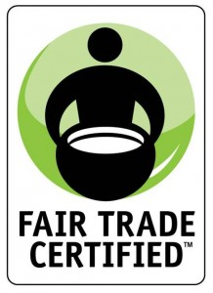
Fair Trade: A way out of poverty?

Your task will be to choose a Fair Trade Product and trace it back to its
country of origin (LDC).

You will write 4 paragraphs including the following elements:

Paragraph 1: Choose a Fair Trade Product and trace it to an LDC. Explain the product and why it is found in the LDC. Discuss how the Free Trade Product has benefitted the producers and workers in the country.

Paragraph 2: Where is the product grown/processed/sold? (Primary, secondary, tertiary)… in other words, trace the processing of the product.

Paragraph 3: Rostow’s Stage (determine/explain why the LDC fits into a specific stage)

Paragraph 4: What other efforts could be done or have been done in the country to assist in development (Non-Government Organizations (NGOs), World Trade Organization (WTO), and Foreign Direct Investment (FDI)). How could the LDC increase the standard of living of its people, and make the nation more competitive on the world market? How could the LDC use its natural resources to build-up its nation, or to trade with other nations? What tools, that we have discussed in class, could be utilized in order to accomplish this?

Website Resources to get you started:
- Fair Trade USA- http://fairtradeusa.org/products-partners
- Fair Trade Federation - http://www.fairtradefederation.org
- Human Development Reports: http://hdr.undp.org/en/content/human-development-index-hdi
- World Fact Book- https://www.cia.gov/library/publications/the-world-factbook/

Product Choices:

- Apparel and Home Goods
- Beans and Grains
- Cocoa
- Coffee
- Fruits/vegetables
- Nuts/oil seeds
- Tea
- Sugar
- Herbs and Spices
- Seafood
- Body care

