Objective: Create an isogloss map for a given concept/idea.
Directions: Using as many colors as needed, create an isogloss map. You should create a key and use different colors to represent the different words used to define your give concept/idea.
Concept/Idea: How a group of two or more people is addressed

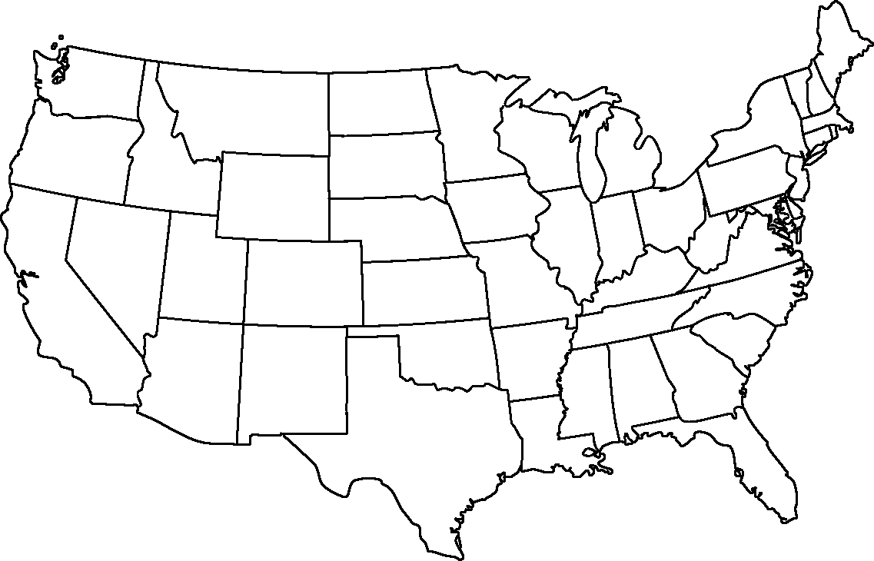
Why are isoglosses sometimes difficult to identify?

Objective: Create an isogloss map for a given concept/idea.
Directions: Using as many colors as needed, create an isogloss map. You should create a key use different colors to represent the different words used to define your give concept/idea.
Concept/Idea: Rubber soled shoes worn in gym class or for athletic activities

Why are isoglosses sometimes difficult to identify?
Objective: Create an isogloss map for a given concept/idea.
Directions: Using as many colors as needed, create an isogloss map. You should create a key and use different colors to represent the different words used to define your give concept/idea.
Concept/Idea: When rain falls while the sun is shining

Why are isoglosses sometimes difficult to identify?
Objective: Create an isogloss map for a given concept/idea.
Directions: Using as many colors as needed, create an isogloss map. You should create a key and use different colors to represent the different words used to define your give concept/idea.
Concept/Idea: Something that is diagonal from you (like across both streets at an intersection)

Why are isoglosses sometimes difficult to identify?
Objective: Create an isogloss map for a given concept/idea.
Directions: Using as many colors as needed, create an isogloss map. You should create a key and use different colors to represent the different words used to define your give concept/idea.
Concept/Idea: Sweetened carbonated beverage

Why are isoglosses sometimes difficult to identify?
Objective: Create an isogloss map for a given concept/idea.
Directions: Using as many colors as needed, create an isogloss map. You should create a key and use different colors to represent the different words used to define your give concept/idea.
Concept/Idea: Small gray bug that curls up into a ball when it is touched

Why are isoglosses sometimes difficult to identify?
Objective: Create an isogloss map for a given concept/idea.
Directions: Using as many colors as needed, create an isogloss map. You should create a key and use different colors to represent the different words used to define your give concept/idea.
Concept/Idea: The thing you drink water from in public places or at school

Why are isoglosses sometimes difficult to identify?
Objective: Create an isogloss map for a given concept/idea.
Directions: Using as many colors as needed, create an isogloss map. You should create a key and use different colors to represent the different words used to define your give concept/idea.
Concept/Idea: A traffic situation in which several roads meets in a circle

Why are isoglosses sometimes difficult to identify?
Objective: Create an isogloss map for a given concept/idea.
Directions: Using as many colors as needed, create an isogloss map. You should create a key and use different colors to represent the different words used to define your give concept/idea.
Concept/Idea: An easy high school or college class

Why are isoglosses sometimes difficult to identify?
Objective: Create an isogloss map for a given concept/idea.
Directions: Using as many colors as needed, create an isogloss map. You should create a key and use different colors to represent the different words used to define your give concept/idea.
Concept/Idea: A drive thru liquor store

Why are isoglosses sometimes difficult to identify?
Objective: Create an isogloss map for a given concept/idea.
Directions: Using as many colors as needed, create an isogloss map. You should create a key and use different colors to represent the different words used to define your give concept/idea.
Concept/Idea: The area of grass in the middle of some streets

Why are isoglosses sometimes difficult to identify?
Objective: Create an isogloss map for a given concept/idea.
Directions: Using as many colors as needed, create an isogloss map. You should create a key and use different colors to represent the different words used to define your give concept/idea.
Concept/Idea: The sale of unwanted items on your porch, in your yard, etc.

Why are isoglosses sometimes difficult to identify?
Objective: Create an isogloss map for a given concept/idea.
Directions: Using as many colors as needed, create an isogloss map. You should create a key and use different colors to represent the different words used to define your give concept/idea.
Concept/Idea: The big road on which you drive relatively fast

Why are isoglosses sometimes difficult to identify?
Objective: Create an isogloss map for a given concept/idea.
Directions: Using as many colors as needed, create an isogloss map. You should create a key and use different colors to represent the different words used to define your give concept/idea.
Concept/Idea: Small road parallel to the highway

Why are isoglosses sometimes difficult to identify?
Objective: Create an isogloss map for a given concept/idea.
Directions: Using as many colors as needed, create an isogloss map. You should create a key and use different colors to represent the different words used to define your give concept/idea.
Concept/Idea: The small freshwater lobster often found in lakes and streams

Why are isoglosses sometimes difficult to identify?

