LATITUDE AND LONGITUDE LAB
1. The lines running north/south (up and down) represent degrees of___________________ which is measured from the ____________________in an__________ and ___________direction. These lines are known also as____________________.
2. The lines running east/west (left to right) represent degrees of____________________ which is measured from the ____________________ in a ______ and ________direction. These lines are known also as____________________.
3. The geographic grid used on the globe is based on the division of a circle in _______degrees. Each degree is divided into _______equal parts called minutes, and each minute into _______equal parts called seconds.
4. Latitude is numbered from ____________________ degrees at the equator to ____________________ degrees at either pole.
5. Longitude is numbered from ____________________ degrees at the prime meridian to ____________________degrees at the International Date Line.
USE THE FIGURE BELOW TO ANSWER QUESTIONS 6-11
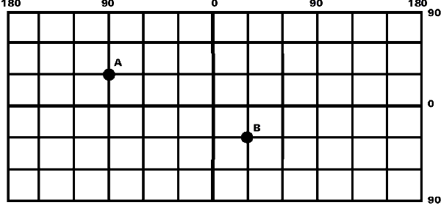
6. What are the coordinates of point A?_____________________
7. Locate the same coordinates on a globe. In what country is point A located? _____________________
8. What are the coordinates of point B? _____________________
9. Locate the same coordinates on the globe. In what country is point B located? ___________________
10. Locate a point at 10 ° South Latitude and 45 ° West Longitude on the grid. Mark it C.
11. Locate a point at 20 ° North Latitude and 75 ° East Longitude on the grid. Mark it D.
12. Write the following in their correct form:
- 60 degrees, 29 minutes, 5 seconds, North Latitude ____________________
- 10 degrees, 20 minutes, 50 seconds, South Latitude ____________________
- 125 degrees, 45 minutes, 3 seconds, West Longitude ____________________
13. Identify the errors in the following. Write if it is a measure of latitude or longitude.
- 89° 47' 65" S ________________________________________________________
- 185° 24' 37" E _______________________________________________________
- 65° 77' 42" W _______________________________________________________
- 40° 50" 21' S ________________________________________________________
14. What is the latitude and longitude of Chicago Ill.?
15. What large city has a similar latitude to that of Chicago (Europe)?
16. What is this city’s Latitude and longitude? _____________________
17. What large city in Asia has a similar latitude to that of Chicago? ____________________
18. What is this city's Latitude and Longitude? _____________________
19. The term "antipodes" refers to two places on opposite sides of the earth so that a straight line drawn through the earth from one to the other passes through the center of the earth. To be exact antipodes, two places must be 180 ° of longitude away from each other, antipode must be as many degrees north latitude as the other is south latitude.
What are the coordinates of the antipode of Chicago? ____________________

What is the nearest large land mass? ____________________

What is the nearest large city? ____________________

