AP Human Geography Name _______________________________
Vacation FRQ

A B
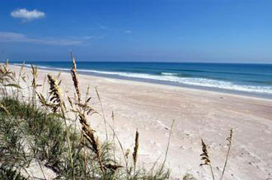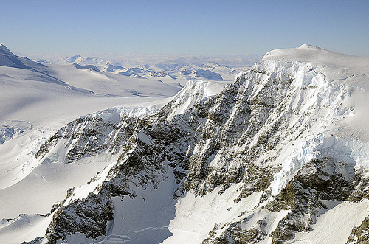
Source: NASA.gov
- Summer is a time when many people travel away from home. They must decide which type of location to spend their time away from home.
a. Define the term vacation.
- Identify physical feature A above and list 2 activities a person could do there.
- Identify physical feature B above and list 2 activities a person could do there.
- Describe which location would most likely be visited by a family with small children.

Use the ABCD’s of Writing the FRQ to prepare this prompt to be answered:
- Attack the prompt
- Brainstorm possible answers
- Choose the order of your responses
- Detect errors before turning in

When writing your answer:
- Set up your answer in the same format as the question
- Label all parts
- Use complete sentences, not bullets.
- Write legibly in ink
____________________________________________________________________________________________________________________________________________________________________________________________________________________________________________________________________________________________________________________________________________________________________________________________________________________________________________________________________________________
____________________________________________________________________________________________________________________________________________________________________________________________________________________________________________________________________________________________________________________________________________________________________________________________________________________________________________________________________________________
____________________________________________________________________________________________________________________________________________________________________________________________________________________________________________________________________________________________________________________________________________________________________________________________________________________________________________________________________________________
____________________________________________________________________________________________________________________________________________________________________________________________________________________________________________________________________________________________________________________________________________________________________________________________________________________________________________________________________________________
____________________________________________________________________________________________________________________________________________________________________________________________________________________________________________________________________________________________________________________________________________________________________________________________________________________________________________________________________________________
____________________________________________________________________________________________________________________________________________________________________________________________________________________________________________________________________________________________________________________________________________________________________________________________________________________________________________________________________________________
__________________________________________________________________________________________________________________________________________________________________________________________________________________________________________

