**College Prep Stat**

**Review for Chapter 11 Test**

**1. Measuring Weights**  When certain quantities are measured, based on the principle the last digits tend to be uniformly distributed, but if they are estimated or reported, the last digits tend to have disproportionately more 0s or 5s. The last digits of the September weights (Freshman 15) in Data Set 3 in Appendix B are summarized in the table below. Use a 0.05 significance level to test the claim that the last digits of occur with the same frequency. Based on the observed digits, what can be inferred about the procedure used to obtain the weights?

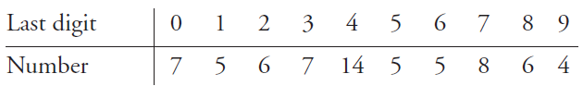

**2. Lightning Deaths** Listed below are the numbers of deaths from lightning on the different days of the week. The deaths were recorded for a recent period of 35 years (based on data from the National Oceanic and Atmospheric Administration). Use a 0.01 significance level to test the claim that deaths from lightning occur on the different days with the same frequency. Can you provide an explanation for the result?

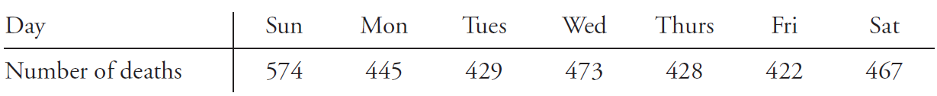

**3. Participation in Clinical Trials by Race** Researchers conducted a study to investigate racial disparity in clinical trials of cancer. Among the randomly selected participants, 644 were white, 23 were Hispanic, 69 were black, 14 were Islander, and 2 were American Native. The proportions of the U.S. population of the same groups are 0.757, 0.091, 0.108, 0.038, and 0.007, respectively. (Based on data from “Participation in Clinical

Trials,” by Murthy, Krumholz, and Gross, *Journal of the American Medical Association,* Vol. 291, No. 22.) Use a 0.05 significance level to test the claim that the participants fit the same distribution as the U.S. population. Why is it important to have proportionate representation in such clinical trials?

**4. Do World War II Bomb Hits Fit a Poisson Distribution?** In analyzing hits by V-1 buzz bombs in World War II, South London was subdivided into regions, each with an area of 0.25 km2. Shown below is a table of actual frequencies of hits and the frequencies expected with the Poisson distribution. (The Poisson distribution is described in Section 5-5.) Use the values listed and a 0.05 significance level to test the claim that the actual frequencies fit a Poisson distribution.

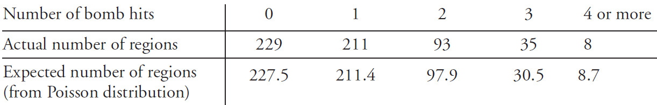

**5. Genetics** The Advanced Placement Biology class at Mount Pearl Senior High School conducted genetics experiments with fruit flies, and the results in the following table are based on the results that they obtained. Use a 0.05 significance level to test the claim that the observed frequencies agree with the proportions that were expected according to principles of genetics.

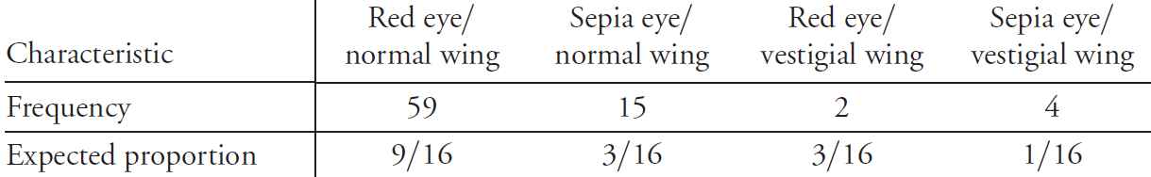

**6. Polio Vaccine** Results of a test of the Salk vaccine against polio are summarized in the table below. We need to test the claim that getting paralytic polio is independent of whether the child was treated with the Salk vaccine or was given a placebo. Based on the *P*-value, what conclusion should we make? Does the vaccine appear to be effective? Can we conclude that the Salk vaccine causes a decrease in the rate of paralytic polio? Why or why not?

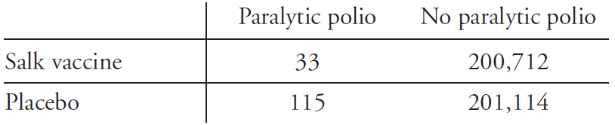

**7. Crime and Strangers** The table below lists data obtained from randomly selected crime victims (based on data from the U.S. Department of Justice). What can we conclude?

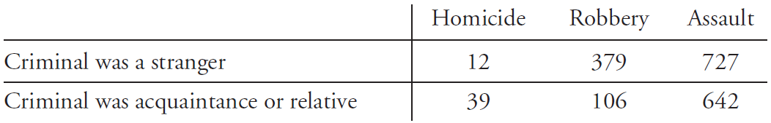

**8. Open Roof or Closed Roof?** In a recent baseball World Series, the Houston Astros wanted to close the roof on their domed stadium so that fans could make noise and give the team a better advantage at home. However, the Astros were ordered to keep the roof open, unless weather conditions justified closing it. But does the closed roof really help the Astros? The table below shows the results from home games during the season leading up to the World Series. Use a 0.05 significance level to test for independence between wins and whether the roof is open or closed. Does it appear that a closed roof really gives the Astros an advantage?

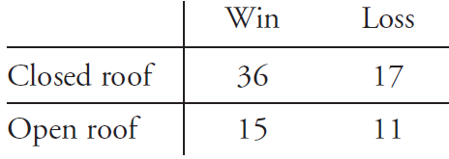

**9. Testing a Lie Detector** The table below includes results from polygraph (lie detector) experiments conducted by researchers Charles R. Honts (Boise State University) and Gordon H. Barland (Department of Defense Polygraph Institute). In each case, it was known if the subject lied or did not lie, so the table indicates when the polygraph test was correct. Use a 0.05 significance level to test the claim that whether a subject lies is independent of the polygraph test indication. Do the results suggest that polygraphs are effective in distinguishing between truths and lies?

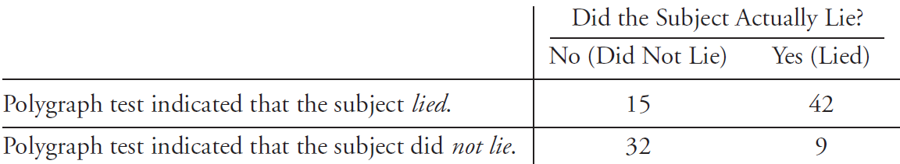

**10. Is the Vaccine Effective?** In a *USA Today* article about an experimental vaccine for children, the following statement was presented: “In a trial involving 1602 children, only 14 (1%) of the 1070 who received the vaccine developed the flu, compared with 95 (18%) of the 532 who got a placebo.” The data are shown in the table below. Use a 0.05 significance level to test for independence between the variable of treatment (vaccine or placebo) and the variable representing flu (developed flu, did not develop flu). Does the vaccine appear to be effective?

