****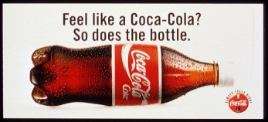**Chapter 1 -- Deceptive Advertising Video Project**

**Name(s) (10 pts): ___________________________________________________________________________________**

**Note: The student’s name(s) MUST be in FULL and be EXACTLY THE SAME AS the one(s) in Tyler System. Otherwise will lose 1 point for each name.**

The purpose of statistics is to improve your skills in interpreting information based on data. Instead of blindly using formulas and procedures, you must think carefully about the **context** of the data, the **source** of the data, **the method used in data collection**, the **conclusions** reached, and the **practical implications**. This project is designed to help you start this way of thinking and analyzing.

**Tasks**

* Find one video advertisement that you believe is purposely being deceptive or does not provide enough information to support their claim.
* Prepare a brief 2 minute explanation to present to the class of why you are skeptical of the advertisement you selected. You should consider and **include the following elements in your explanation (6 pts each)**:
  + The context of the data in the advertisement (What is the goal of your advertisement?).
  + The source of the data (Who or what company created the advertisement?).
  + The sampling method used to find the data (If a sample was obtained).
  + The conclusions made from the advertisement.
  + The practical implications the advertisement implies based on the data.
* Please make sure the advertisement you select is appropriate to show in class.
* Put all the student name(s) in the project group on this sheet and submit it in before your presentation.

Grade: _________/40