College Prep Stats Name _____________________________________

REVIEW for Final Exam

Chapter 6

For numbers 1 – 3, find the area of the shaded region.

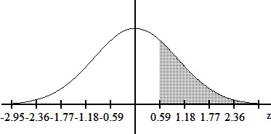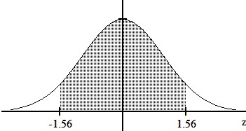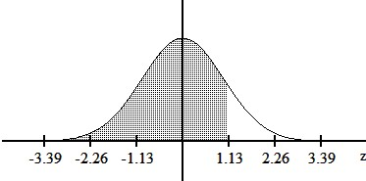

1. 2. 3.

a) 0.1292 b) 0.8485 a) 0.7224 b) 0.2776 a) 0.1188 b) 0.9406

c) 0.8708 d) 0.8907 c) 0.2190 d) 0.2224 c) 0.0594 d) 0.8812

For numbers 4 and 5, find the indicated *z* score.

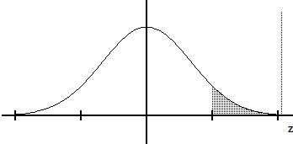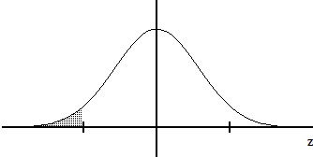4. The shaded area is 0.040 5. The shaded area is 0.0694

a) –1.75 b) –1.48 a) 1.39 b) 1.26

c) –1.63 d) –1.89 c) 1.45 d) 1.48

6. Find the indicated value for *z*0.005.

a) 2.015 b) 2.835 c) 2.535 d) 2.575

For numbers 7 and 8, find the area of the shaded region. The graph depicts IQ scores of adults, and those scores are normally distributed with a mean of 100 and a standard deviation of 15 (as on the Wechsler test).

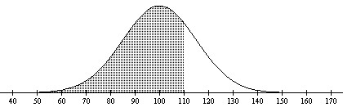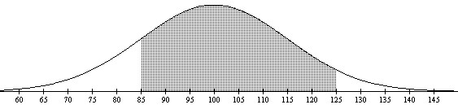

7. 8.

a) 0.4400 b) 0.7486 a) 0.7619 b) 0.7938

c) 0.6293 d) 0.8051 c) 0.7303 d) 0.7745

9. Scores on an English test are normally distributed with a mean of 37.6 and a standard deviation of 7.6. Find the score that separates the top 59% from the bottom 41%

a) 42.1 b) 35.9 c) 39.3 d) 33.1

10. Suppose that replacement times for washing machines are normally distributed with a mean of 9.5 years and a standard deviation of 1.8 years. Find the replacement time that separates the top 18% from the bottom 82%.

a) 11.2 years b) 9.8 years c) 7.8 years d) 10.5 years

11. The diameters of pencils produced by a certain machine are normally distributed with a mean of 0.30 inches and a standard deviation of 0.01 inches. What is the probability that the diameter of a randomly selected pencil will be less than 0.285 inches?

a) 0.0596 b) 0.0668 c) 0.9332 d) 0.4332

12. The weekly salaries of teachers in one state are normally distributed with a mean of $490 and a standard deviation of $45. What is the probability that a randomly selected teacher earns more than $525 a week?

a) 0.7823 b) 0.2177 c) 0.1003 d) 0.2823

13. In one region, the September energy consumption levels for single-family homes are found to be normally distributed with a mean of 1050 kWh and a standard deviation of 218 kWh. If 50 different homes are randomly selected, find the probability that their mean energy consumption level for September is greater than 1075 kWh.

a) 0.2090 b) 0.4562 c) 0.0438 d) 0.2910

14. Suppose that replacement times for washing machines are normally distributed with a mean of 9.3 years and a standard deviation of 1.1 years. Find the probability that 70 randomly selected washing machines will have a mean replacement time less than 9.1 years.

a) 0.4357 b) 0.4286 c) 0.0643 d) 0.0714

Chapter 7

15. Find the critical value *z*\* (*z*α/2) that corresponds to a 91% confidence level.

a) 1.75 b) 1.34 c) 1.645 d) 1.70

16. Find the critical value *z*\* (*z*α/2) that corresponds to a 94% confidence level.

a) 2.75 b) 1.96 c) 1.555 d) 1.88

17. Find the margin of error with 95% confidence; *n* = 2428, *x* = 1704

a) 0.0204 b) 0.0155 c) 0.0182 d) 0.0246

18. Find the margin of error with 95% confidence; the sample size is 10,000, of which 40% are successes.

a) 0.00720 b) 0.0126 c) 0.0110 d) 0.00960

19. Find the margin of error for systolic blood pressures for women aged 18-24 with 94% confidence; *n* = 92, = 112.1 mm Hg, *σ* = 13.5 mm Hg.

a) 2.6 mm Hg b) 2.2 mm Hg c) 47.1 mm Hg d) 2.3 mm Hg

20. Find the margin of error for telephone calls directed by a local telephone company with 90% confidence, *n* = 560, *σ* = 3.6.

a) 0.092 min b) 0.011 min c) 0.006 min d) 0.250 min

21. Thirty randomly selected students took the calculus final. If the sample mean was 83 and the standard deviation was 13.5, construct a 99% confidence interval for the mean score of all students.

a) 76.23 < μ < 89.77 b) 76.93 < μ < 89.07 c) 76.21 < μ < 89.79 d) 78.81 < μ < 87.19

22. A sociologist develops a test to measure attitudes towards public transportation, and 27 randomly selected subjects are given the test. Their mean score is 76.2 and their standard deviation is 21.4. Construct the 95% confidence interval for the mean score of all such subjects.

a) 67.7< μ < 84.7 b) 64.2 < μ < 88.2 c) 74.6 < μ < 77.8 d) 69.2 < μ < 83.2

For numbers 23 – 25, do one of the following as appropriate: a) Find the critical value *z*\* (*z*α/2), b) find the critical value *t*\* (*t*α/2), or c) state that neither the normal nor the *t* distribution applies.

23. 98%; n = 7; σ = 27; population appears to be normally distributed.

a) *z*\* = 2.05 b) *t*\* = 2.575 c) Neither d) *z*\* = 2.33

24. 90%; n = 10; σ is unknown; population appears to be normally distributed.

a) *t*\* = 1.833 b) *t*\* = 1.812 c) *z*\* = 1.383 d) Neither

25. 90%; n =9; σ = 4.2; population appears to be very skewed.

a) *z*\* = 2.896 b) Neither c) *z*\* = 2.306 d) *z*\* = 2.365

26. Express the confidence interval 0.047 < *p* < 0.507 in the form of .

a) 0.23 ± 0.277 b) 0.23 ± 0.5 c) 0.277 ± 0.5 d) 0.277 ± 0.23

Chapter 8

**Use the following information for numbers 27 – 30.**

A psychologist claims that more than 4.1 percent of the population suffers from professional problems due to extreme shyness. In a sample of 30, is found to be 5%. Use *p*, the true percentage of the population that suffers from extreme shyness. Use a 0.05 significance level.

27. Identify the null hypothesis and alternative hypothesis.

a) *H*0: *p* < 0.041, *H*1: *p* ≥ 0.041 b) *H*0: *p* = 0.041, *H*1: *p* ≠ 0.041 c) *H*0: *p* = 0.041, *H*1: *p* > 0.041 d) *H*0: *p* ≥ 0.041, *H*1: *p* < 0.041

28. Calculate the test statistic.

a) 0.249 b) 0.117 c) 0.011 d) 0.582

29. Determine the *P* – value.

a) 0.201 b) 0.006 c) 0.117 d) 0.402

30. What is the conclusion?

a) Fail to reject *H*0. There is not enough evidence to suggest that more than 4.1 percent of the population suffers from professional problems due to extreme shyness.

b) Fail to reject *H*0. There is enough evidence to suggest that more than 4.1 percent of the population suffers from professional problems due to extreme shyness.

c) Reject *H*0. There is not enough evidence to suggest that more than 4.1 percent of the population suffers from professional problems due to extreme shyness.

d) Reject *H*0. There is enough evidence to suggest that more than 4.1 percent of the population suffers from professional problems due to extreme shyness.

**Use the following information for numbers 31 – 34.**

The manufacturer of a refrigerator system for beer kegs produces refrigerators that are supposed to maintain a true mean temperature, *μ*, of 43°F, ideal for a certain type of German pilsner. The owner of the brewery does not agree with the refrigerator manufacturer, and claims he can prove that the true mean temperature is incorrect. In a sample of 40 refrigerators the mean is 38.1°F with a standard deviation of 10.5°F. Use a 0.05 significance level.

31. Identify the null hypothesis and alternative hypothesis.

a) *H*0: *µ* = 43°, *H*1: *µ* < 43° b) *H*0: *µ* = 43°, *H*1: *µ* ≠ 43° c) *H*0: *µ* = 43°, *H*1: *µ* > 43° d) *H*0: ** = 43°, *H*1: ** ≠ 43°

32. Calculate the test statistic.

a) –1.95 b) –2.95 c) 2.95 d) 1.95

33. Determine the *P* – value.

a) 0.005 b) 0.124 c) 0.009 d) 0.105

34. What is the conclusion?

a) Fail to reject *H*0. There is not enough evidence to suggest that the true mean temperature is not 43°.

b) Fail to reject *H*0. There is enough evidence to suggest that the true mean temperature is not 43°.

c) Reject *H*0. There is not enough evidence to suggest that the true mean temperature is not 43°.

d) Reject *H*0. There is enough evidence to suggest that the true mean temperature is not 43°.

Chapter 9

**Use the following information for numbers 35 – 39.**

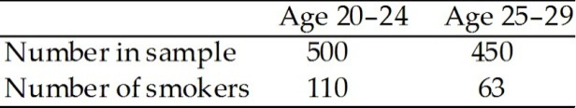The table shows the number of smokers in a random sample of 500 adults aged 20-24 and the number of smokers in a random sample of 450 adults aged 25-29. Do the data provide sufficient evidence that the proportion of smokers in the 20-24 age group is different from the proportion of smokers in the 25-29 age group at the *α* = 0.10 significance level.

35. State the null hypothesis and the alternative hypothesis.

a) *H*0: *p*1 = *p*2; *H*1: *p*1 < *p*2 b) *H*0: *p*1 = *p*2; *H*1: *p*1 > *p*2 c) *H*0: *p*1 = *p*2; *H*1: *p*1 ≠ *p*2 d) *H*0:; *H*1: 

36. What is the pooled estimate,?

a) 0.22 b) 0.14 c) 0.182 d) 5.491

37. Calculate the test statistic.

a) –3.191 b) 0.703 c) 3.191 d) 0.512

38. Determine the *P* – value.

a) 0.0007 b) 0.001 c) 0.140 d) 0.633

39. What is the conclusion?

a) Fail to reject *H*0. There is not enough evidence to suggest that the proportion of smokers in the 20 – 24 age group is not the same as the proportion of smokers in the 25 – 29 age group.

b) Fail to reject *H*0. There is enough evidence to suggest that the proportion of smokers in the 20 – 24 age group is not the same as the proportion of smokers in the 25 – 29 age group.

c) Reject *H*0. There is not enough evidence to suggest that the proportion of smokers in the 20 – 24 age group is not the same as the proportion of smokers in the 25 – 29 age group.

d) Reject *H*0. There is enough evidence to suggest that the proportion of smokers in the 20 – 24 age group is not the same as the proportion of smokers in the 25 – 29 age group.

**Use the following information for numbers 40 – 43.**

A researcher was interested in comparing the response times of two different cab companies. Companies A and B were each called at 50 randomly selected times. The calls to company A were made independently of the calls to company B. The response times for each call were recorded. The summary statistics were as follows:

Company A Company B

Mean response time 7.6 mins 6.9 mins

Standard deviation 1.4 mins 1.7 mins

Use a 0.02 significance level to test the claim that the mean response time for company A is the same as the mean response time for company B. Use the P-value method of hypothesis testing.

40. State the null hypothesis and the alternative hypothesis.

a) *H*0: *µ*1 = *µ* 2; *H*1: *µ* 1 < *µ* 2 b) *H*0: *µ* 1 = *µ* 2; *H*1: *µ* 1 > *µ* 2 c) *H*0: *µ* 1 = *µ* 2; *H*1: *µ* 1 ≠ *µ* 2 d) *H*0: *µ* 1 ≠ *µ* 2; *H*1: *µ* 1 = *µ* 2

41. What is the test statistic?

a) 2.248 b) –9.557 c) –4.779 d) 7.168

42. What is the *P* – value?

a) 0.921 b) 5.339 c) 0.029 d) 0

43. What is the conclusion?

a) Fail to reject *H*0. There is not enough evidence to suggest that the mean response time for company A is not the same as the mean response time for company B.

b) Fail to reject *H*0. There is enough evidence to suggest that the mean response time for company A is not the same as the mean response time for company B.

c) Reject *H*0. There is not enough evidence to suggest that the mean response time for company A is not the same as the mean response time for company B.

d) Reject *H*0. There is enough evidence to suggest that the mean response time for company A is not the same as the mean response time for company B.

**Use the following information for numbers 44 – 48.**

Listed below are the numbers of words (in thousands) males and females in randomly selected *couples* spoke in a day (based on data from “Are Women Really More Talkative Than Men?” by Mehl, Vazire, Ramierz-Esparza, Slatcher, and Pennebaker, *Science*, Vol. 317, No. 5834).

|  |  |  |  |  |  |  |  |  |  |  |
| --- | --- | --- | --- | --- | --- | --- | --- | --- | --- | --- |
| Female: | 9 | 12 | 38 | 28 | 21 | 16 | 34 | 20 | 18 | 21 |
| Male: | 9 | 25 | 16 | 21 | 15 | 8 | 14 | 19 | 8 | 14 |

Use a 0.04 significance level to test the claim that among couples, females are more talkative than males.

44. What are the null hypothesis and the alternative hypothesis?

a) *H*0: *µd* = 0; *H*1: *µd* < 0 b) *H*0: *µd* = 0; *H*1: *µd*> 0 c) *H*0: *µd* = 0; *H*1: *µd* ≠ 0 d) *H*0: *µd* > 0; *H*1: *µd*< 0

45. What areand *sd*?

a)  b)  c)  d) 

46. What is the test statistic?

a) 2.163 b) 0.216 c) 0.684 d) 2.15

47. What is the *p*-value?

a) 0.015 b) 0.029 c) 0.043 d) 0.057

48. What is the conclusion?

a) Fail to reject *H*0. There is not enough evidence to suggest that, among couples, females are more talkative than males.

b) Fail to reject *H*0. There is enough evidence to suggest that, among couples, females are more talkative than males.

c) Reject *H*0. There is not enough evidence to suggest that, among couples, females are more talkative than males.

d) Reject *H*0. There is enough evidence to suggest that, among couples, females are more talkative than males.