**Name:_________________________________**

**9-2 *Solving Quadratic Equations by Graphing*** *PRACTICE*

**Solve each equation by graphing.**

**1. $x^{2}$**  – 2*x* + 3 = 0 **2. $c^{2}$**  + 6*c* + 8 = 0

Follow this QR code for videos on how to perform each one of these problems.

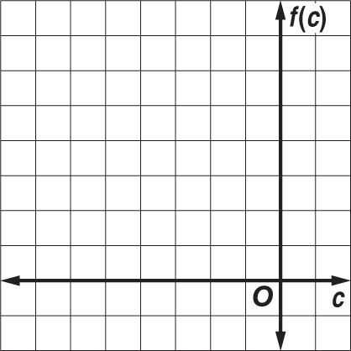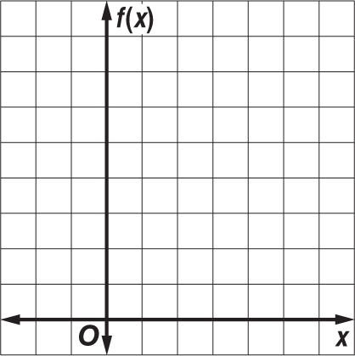

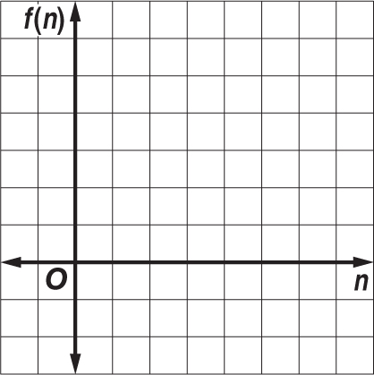 **3. $a^{2}$**  – 2*a* = –1 **4. $n^{2}$**  – 7*n* = –10

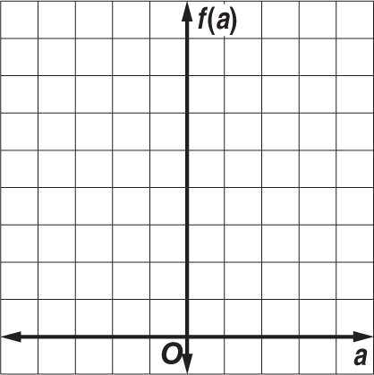

**Solve each equation by graphing. If integral roots cannot be found, estimate the roots to the nearest tenth.**

**5. $p^{2}$**  + 4*p* + 2 = 0 **6. $x^{2}$**  + *x* – 3 = 0

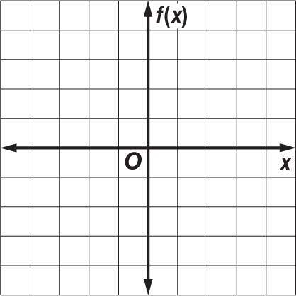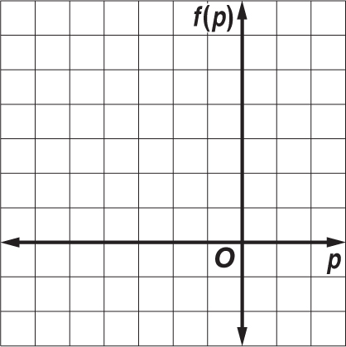

**7. $d^{2}$**  + 6*d* = –3 **8. $h^{2}$**  + 1 = 4*h*

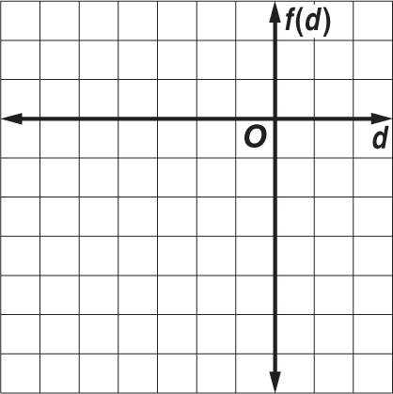

**Name:_________________________________**

**9-2 *Solving Quadratic Equations by Graphing*** *HOMEWORK*

**Solve each equation by graphing.**

**1. $x^{2}$**  – 5*x* + 6 = 0 **2. $w^{2}$**  + 6*w* + 9 = 0 **3. $b^{2}$**  – 3*b* + 4 = 0

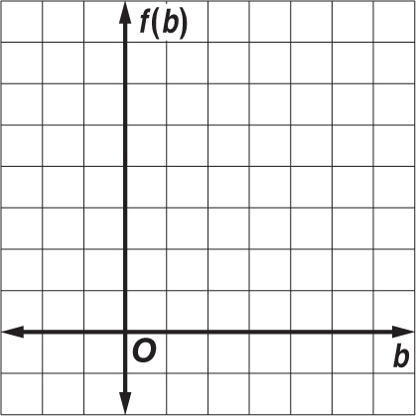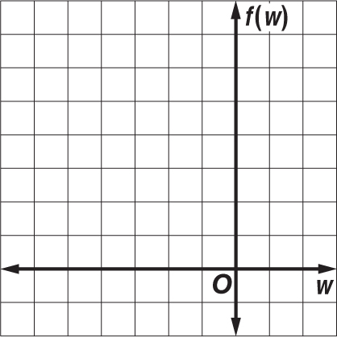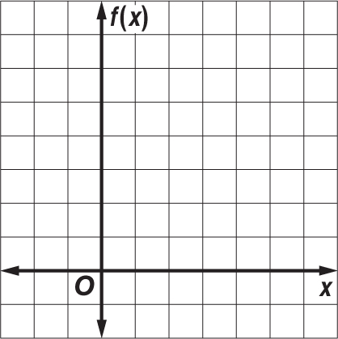

**Solve each equation by graphing. If integral roots cannot be found, estimate the roots to the nearest tenth.**

**4. $p^{2}$**  + 4*p* = 3 **5.** 2 $m^{2}$ + 5 = 10*m* **6.** 2 $v^{2}$ + 8*v* = –7

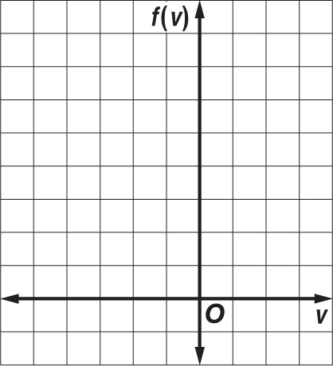

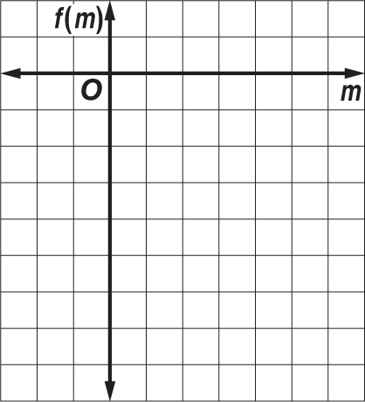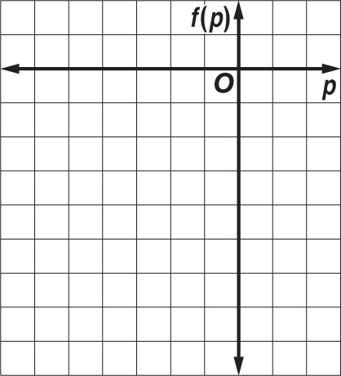

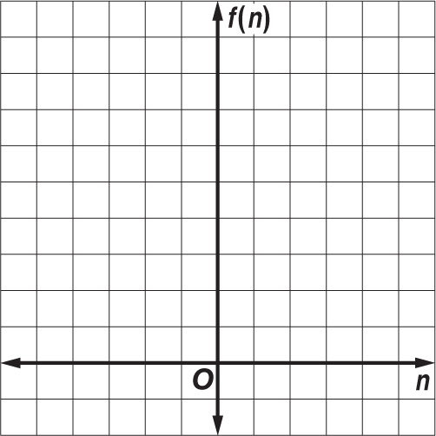 **7. NUMBER THEORY** Two numbers have a sum of 2 and a product of –8. The quadratic equation – $n^{2}$ + 2*n* + 8 = 0 can be used to determine the two numbers.

**a.** Graph the related function *f*(*n*) = – $n^{2}$ + 2*n* + 8 and determine its  
*x*-intercepts.

**b.** What are the two numbers?