**Comic Strips**

[](http://www.google.com/url?sa=i&rct=j&q=&esrc=s&source=images&cd=&cad=rja&uact=8&ved=0ahUKEwj774uQi83MAhWFzIMKHTI8BGUQjRwIBw&url=http://thaparpoetrysociety.blogspot.com/2011/09/poetry-comics-cartoon-strips.html&psig=AFQjCNEsqrHp0_RCcEE0zNdkSJjfWmJlYQ&ust=1462886525209383)

[](http://www.google.com/url?sa=i&rct=j&q=&esrc=s&source=images&cd=&cad=rja&uact=8&ved=0ahUKEwiwldaoi83MAhVh0YMKHen0B-0QjRwIBw&url=http://toonut.com/&psig=AFQjCNEsqrHp0_RCcEE0zNdkSJjfWmJlYQ&ust=1462886525209383)

[](http://www.google.com/url?sa=i&rct=j&q=&esrc=s&source=images&cd=&cad=rja&uact=8&ved=0ahUKEwj4tp2zi83MAhWrxYMKHeDJBqoQjRwIBw&url=http://www.silly-stuff.com/comic_strips.htm&psig=AFQjCNEsqrHp0_RCcEE0zNdkSJjfWmJlYQ&ust=1462886525209383)

[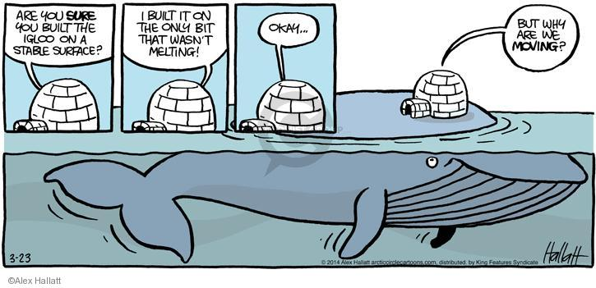](http://www.google.com/url?sa=i&rct=j&q=&esrc=s&source=images&cd=&cad=rja&uact=8&ved=0ahUKEwi55tvt1ufSAhVMyoMKHYiKAjEQjRwIBw&url=http://www.thecomicstrips.com/subject/The-Arctic+Sea+Ice-Comic-Strips-by-Arctic+Circle.php&psig=AFQjCNECEztMoghWh9Ni4Rd1NJ6okbo5yQ&ust=1490188468650038)

**Political Cartoons**

[](https://www.google.com/url?sa=i&rct=j&q=&esrc=s&source=images&cd=&cad=rja&uact=8&ved=0ahUKEwikm87_zqnSAhUj4oMKHdlDA8oQjRwIBw&url=https://www.pinterest.com/hassinasamuel/political-cartoons/&psig=AFQjCNHRgiKSiR0dciPlRCFS4kM1FJEZOg&ust=1488055875864950)

[](http://www.google.com/url?sa=i&rct=j&q=&esrc=s&source=images&cd=&cad=rja&uact=8&ved=0ahUKEwii0NHFz6nSAhVrxYMKHTD1B4AQjRwIBw&url=http://vanessacassie.blogspot.com/2010/02/past-few-weeks-have-been-crazy-ive-done.html&bvm=bv.148073327,d.amc&psig=AFQjCNHl1Xcg4mnKm6M9Mq0dG-CmBbkWCw&ust=1488056148952870)[](http://www.google.com/url?sa=i&rct=j&q=&esrc=s&source=images&cd=&cad=rja&uact=8&ved=0ahUKEwiQy4Gmz6nSAhUl8IMKHfb-Dk4QjRwIBw&url=http://cringechannel.com/forums/topic/cringeworthy-political-cartoons/&bvm=bv.148073327,d.amc&psig=AFQjCNHl1Xcg4mnKm6M9Mq0dG-CmBbkWCw&ust=1488056148952870)