Name:______________________________ Date: ________________
Class Notes
Flow of Energy through a Community
Producers: | Also known as_____________ex.
Consumers: | Also known as __________________ _____________
Types of Consumers
Primary Consumers
(1st Order Consumers)

Secondary Consumers
(2nd Order Consumers)

Tertiary Consumers
(3rd Order Consumers)

Quaternary Consumers
(4th Order Consumer)

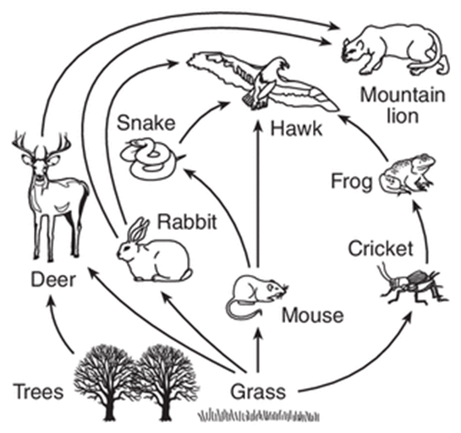 |  | Circle the producers in this picture:  Place a 1 by any primary consumers in this picture.  Place a 2 by any secondary consumers in the picture.  Place a 3 by any tertiary consumers in this picture.
 |  | The arrows in this picture represent:
 |  | This picture shows a:
Food Web

One food chain from this picture would be:

Food Chain

As you move through the food chain, energy is

Scientists estimate only ______________________________________ passes from one level to the next.

Energy cannot be created or destroyed. Where does all of the energy for this community originate from?

Formula for Photosynthesis in words:

_____________ + ______________ ______________ + ______________
plants need energy plants release
Formula for Photosynthesis in chemical formulas:

_____________ + ______________ ____________ + ____________
(these are the reactants or inputs) (these are the products or outputs)

Energy of Photosynthesis:

Photosynthesis takes _____________ energy

and transforms it into __________________ energy.

Answer to the food chain decision:

