Name: _______________________________________________

All living things are made of _______________________________.

Determine if the following things are made of cells:
Object | Biotic or Abiotic | Made of Cells?  Yes or No
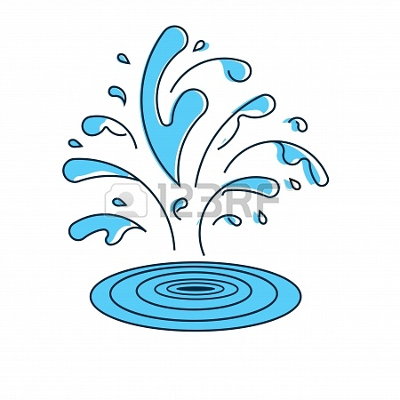

water
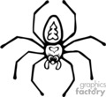

spider

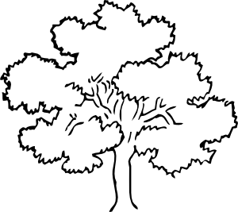

tree
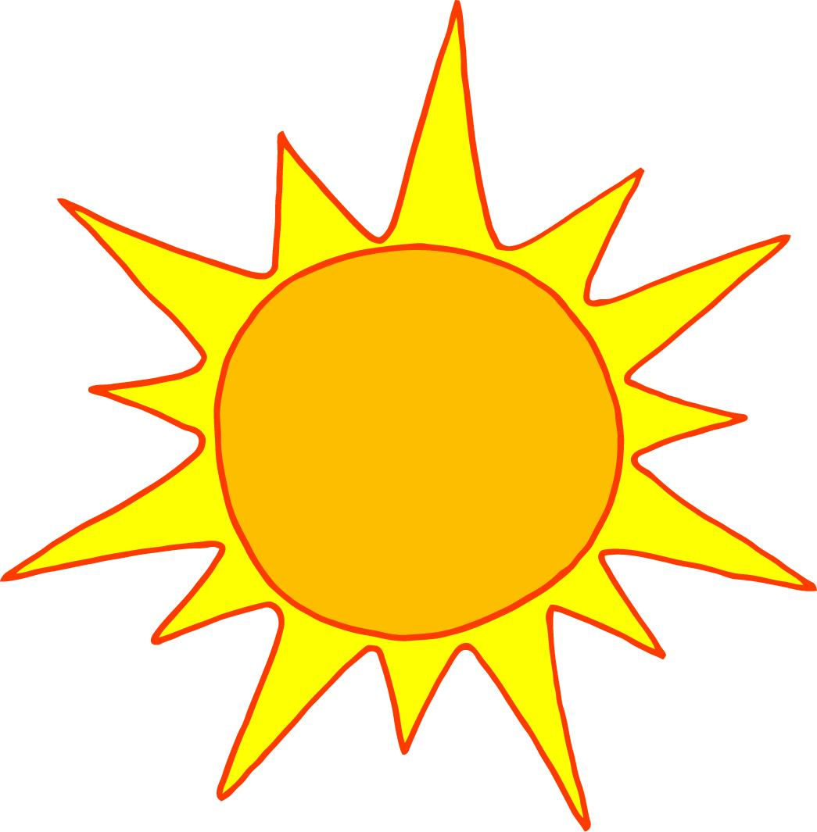
sun

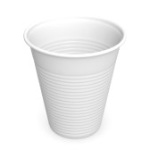
plastic cup

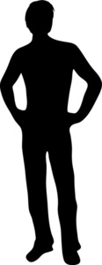

person

http://www.cellsalive.com/howbig.htm

Object we can measure | Size | Measurement
Pin
Top of Pin
Objects we cannot measure | Size
Pollen
Human Blood Cell
Bacteria Cell

Use a T chart to compare the cells on the overhead for similarities and differences.
Similarities Differences
________________________________________________________________________________________________________

We will watch the following video together about cells. While you watch, notice the different things that are happening and be ready to tell me what you see.
http://www.youtube.com/watch?v=gFuEo2ccTPA

