**Blood and Cardio Review**

**Explain the picture below. Be sure to use the numbered parts and refer to them by name. Describe diastole and systole in your explanation. Describe the sounds of the heart as you explain the cycle.**

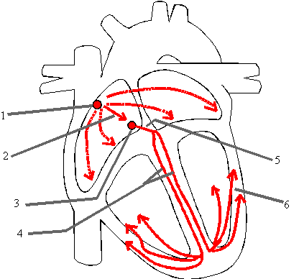

1. **SA Node (pacemaker- causes Atrial contraction)**
2. **Action Potential**
3. **AV Node**
4. **Bundle Branches**
5. **AV Bundle (Bundle of His)**
6. **Purkinje Fibers (when action potential reaches here the ventricles contract)**
7. **Lumen**

**Vasoconstriction**

**Vasodialation**

**Veins**

**Arteries**

**Arterioles**

**Venules**

1. **Valves are to block a back flow in veins so that gravity does not pull the blood downward, veins are also under low pressure and blood can backflow easily without valves**
2. **Milking action and valves of muscles**

**Pull out your pictures of the veins and arteries and check them with the key.**

**Veins- match the vein with its description. Use what you know about terminology to help.**

**Brachiocephalic**

**Common Iliac**

**Hepatic**

**Inferior Vena Cava**

**Internal jugular**

**Renal**

**Subclavian**

**Superior Mesenteric**

**Superior Vena Cava**

___subclavian______________ Vein that receives blood from the arm

_____Renal________________ Vein that drains the kidney

_______Internal Jugular_________________ Vein that drains the brain

_______(right/left) brachiocephalic________ are two veins that become the superior vena cava

______mesenteric_____ Large vein that carries nutrient rich blood from the **digestive organs** to the liver for processing

______inferior vena cava____________ Largest vein below the thorax

______Hepatic________ Vein that drains the liver

______Common Iliac______ Vein that brings blood up from the legs back to the vena cava

**Arteries- match the artery with its description. Use what you know about terminology to help.**

**Aorta**

**Brachiocephalic**

**Common Carotid**

**Coronary**

**External Carotid**

**Hepatic**

**Internal Carotid**

**Renal**

**Subclavian**

**Superior Mesenteric**

_________common carotid______and _______subclavian_________ are two arteries formed by the division of the brachiocephalic artery.

______coronary________First artery that branches off of the aorta which brings oxygen and nutrients to the myocardium

______internal carotid_____________Brings blood to the brain

Common carotid**___**Largest artery of the brain.

____superior mesenteric_________ Artery that supplies most of the small intestine.

____external carotid_____ Major artery, serving the tissues external to the skull.

Use the chart below to distinguish between veins, arteries and capillaries.

|  |  |  |  |
| --- | --- | --- | --- |
| **Characteristic** | **Arteries** | **Veins** | **Capillaries** |
| Strength/Elasticity | Strong and Elastic | Not as strong nor elastic | N/A |
| Pressure | High | Low | N/A |
| Purpose | Move oxygenated blood to various tissues | Bring deoxygenated blood back to the heart | Diffusion of materials to and from cells |
| Location | Deep | Superficial | everywhere |
| Oxygenated/Deoxygenated | Oxygenated  Except pulmonary artery | Deoxygenated  Except pulmonary vein | Both |
| Mechanism for Movement | Pressure from ventricular systole | Muscle movement and valves | N/A |

Draw the path of blood through the heart. Use red for oxygenated blood and blue for deoxygenated blood. Use arrows to show the direction the blood is moving.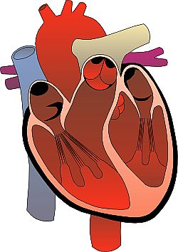 Then name the atria, venticles, interventricular septum, arteries, veins and valves.

**MAKE SURE YOU CAN DO THIS**

**SEND ME A PICTURE IF YOU**

**WANT ME TO CHECK IT**