**Blood and Cardio Review**

**Explain the picture below. Be sure to use the numbered parts and refer to them by name. Describe diastole and systole in your explanation. Describe the sounds of the heart as you explain the cycle.**

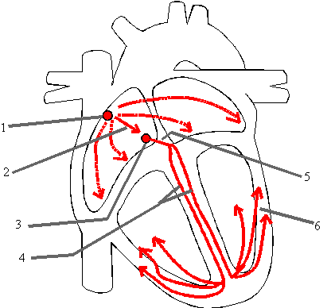



**Explain the cardiac cycle: use systole and diastole in your answer.**

**Pull out your pictures of the veins and arteries to use as you answer these questions.**

**Veins- match the vein with its description. Use what you know about terminology to help.**

**Brachiocephalic**

**Common Iliac**

**Hepatic**

**Inferior Vena Cava**

**Internal jugular**

**Renal**

**Subclavian**

**Superior Mesenteric**

**Superior Vena Cava**

____________________________ Vein that receives blood from the arm

____________________________ Vein that drains the kidney

____________________________ Vein that drains the brain

____________________________ are two veins that become the superior vena cava

____________________________ Large vein that carries nutrient rich blood from the digestive organs to the liver for processing

___________________________ Largest vein below the thorax

___________________________ Vein that drains the liver

___________________________ Vein that brings blood up from the legs back to the vena cava

**Arteries- match the artery with its description. Use what you know about terminology to help.**

**Aorta**

**Brachiocephalic**

**Common Carotid**

**Coronary**

**External Carotid**

**Hepatic**

**Internal Carotid**

**Renal**

**Subclavian**

**Superior Mesenteric**

_____________________________ and ________________________ are two arteries formed by the division of the brachiocephalic artery.

_____________________________ First artery that branches off of the aorta which brings oxygen and nutrients to the myocardium

_____________________________ Brings blood to the brain

_____________________________ Largest artery of the brain.

_____________________________ Artery that supplies most of the small intestine.

_____________________________ Major artery, serving the tissues external to the skull.

Use the chart below to distinguish between veins, arteries and capillaries.

|  |  |  |  |
| --- | --- | --- | --- |
| **Characteristic** | **Arteries** | **Veins** | **Capillaries** |
| Strength/Elasticity |  |  |  |
| Pressure |  |  |  |
| Purpose |  |  |  |
| Location |  |  |  |
| Oxygenated/Deoxygenated |  |  |  |
| Mechanism for Movement |  |  |  |

Draw the path of blood through the heart. Use red for oxygenated blood and blue for deoxygenated blood. Use arrows to show the direction the blood is moving. Then name the atria, ventricles, interventricular septum, arteries, veins and valves.

