**Name:______________________________**

**Cells 2**

**3 Main Parts of the Cell Label this cheek cell with the 3 main**

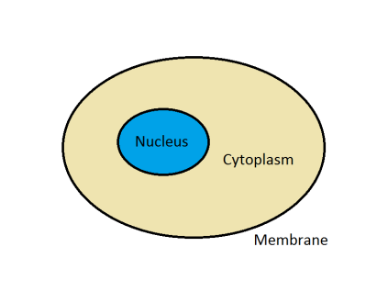 **parts shown in the cartoon cell**

1.___________: ________________________

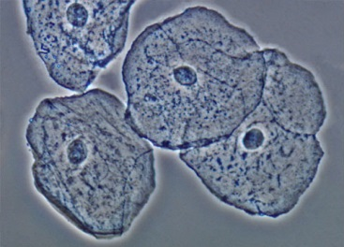

2.___________: ________________________

3.___________: ________________________

|  |  |
| --- | --- |
| DNA | All the ______________ ______________ that tells a cell how to  ___________________ ________________ |
|  | Found in the ______________ of every cell in your body |
|  | Your DNA came from your ___________ and _____________ |
| Gene | Small part of the _______________ |
|  | One specific ________________ for the cell |
|  | There is a gene for ___________________ and a gene for  ____________________ and genes that can cause _______________  in your body. |
| Chromosome | A bunch of __________, twisted together inside the nucleus of a cell |
|  | Humans have _______ chromosomes in every cell |
|  | Chromosomes are found in ___________. |
|  | Mom passes ____________ the chromosomes in a special cell called an ______________. |
|  | Dad passes half of the chromosomes in a special cell called ______________. |

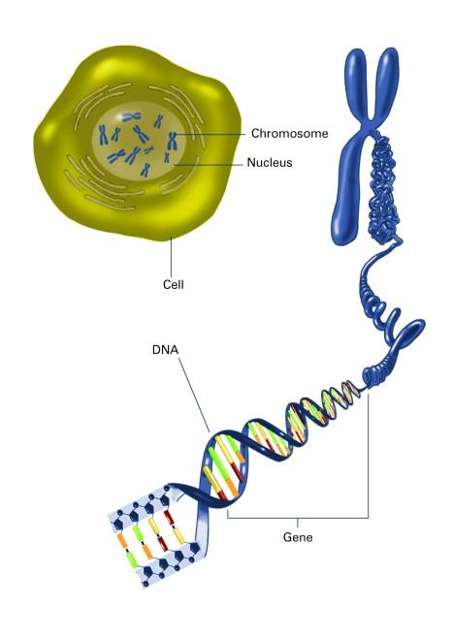

Label the picture: cell, chromosome, DNA, gene and nucleus

3

2

1

5

4

Cells must make new cells. The process of making new cells is called ____________ __________________.

**Brainstorm:** Think of 5 reasons why a cell would need to divide.

|  |  |
| --- | --- |
| **Cell division is necessary for:** | |
| S_____________: |  |
| G_____________: |  |
| R_____________: |  |
| R_____________: |  |
| R_____________: | Unicellular: |
| Multicellular: |

In order for a cell to divide into a new cell that will function properly, the chromosomes (DNA) of the cell must be _______________________. The copying of the chromosomes (DNA) is known as ______________________.

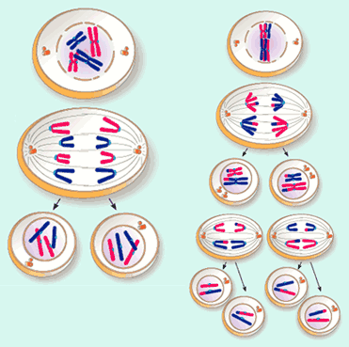

Picture A Picture B