**D I G E S T I V E S Y S T E M**

1. The esophagus is posterior to the trachea. Follow the esophagus through the thoracic cavity to the diaphragm, locating the esophageal hiatus where the esophagus penetrates through the diaphragm to the abdominal cavity. **Photograph the esophageal hiatus. (color:_______________)**

CUTTING: From this point on we will be observing the organs in the abdominopelvic region.

* Continue the midsagittal incision you began through the ventral body wall of the thoracic cavity from the sternum to the pubis.
* Create lateral cuts posterior to the diaphragm from ventral to dorsal side and lateral cuts through the inguinal region from the ventral side as far to the dorsal side as possible, in order to open up “flaps” to view the organs of the abdominopelvic regions.

2. Observe the yellowish, fat-filled “apron” that covers the abdominopelvic region. You can actually pick it up like it is an apron. This is the greater omentum**,** a double layered serous membrane. **Photograph the greater omentum looking like an apron.** **(color:_______________)** Remove the greater omentum by removing it from where it attaches to the greater curvature of the stomach.

3. Observe the peritoneum that lines the abdominal cavity and also covers the exterior of the abdominal organs. **Photograph the parietal peritoneum. (color:_______________)**

4. The next obvious structure in the abdomen is the large, brown or reddish-brown lobed liver. It is located on the right side, inferior to the diaphragm**.** **Photograph the liver. (color:_______________)**

5. Lift the liver and look for a small, possibly greenish sac, the gallbladder, on the inferior surface of the right lobe of the liver. The gall bladder may look like a filled balloon; in this case it is storing bile. If it is deflated, the bile may have spilled out or may not have been stored at this time. Use a blunt probe to remove the connective tissue that is holding the gall bladder to the liver and then pull the gall bladder out from the lobes without detaching it. The small tube attaching the gall bladder to the liver is the bile duct. **Photograph the gall bladder (color:_______________) and bile duct (color:_______________).**

6. To the left of and partially posterior to the liver is the stomach**.** You may need to follow the esophagus to find it. Identify the lesser omentum, the serous membrane that attaches the liver to the lesser curvature of the stomach. **Photograph the lesser omentum.** **(color:_______________)** Remove the liver.

7. Note the constricted junction of the esophagus and the stomach, the cardioesophageal sphincter. At the other end of the stomach is the pyloric sphincter. Pin these junctions. **Photograph the stomach (color:_______________) so that the cardioesophageal sphincter (color:_______________) and the pyloric sphincter (color:_______________) can be seen.**

8. To the left of and posterior to the stomach is the long, narrow, dark colored spleen that hugs the left abdominal wall (not a digestive organ). **Photograph the spleen. (color:_______________)**

9. Find the pancreas. It is pink or brownish-gray and is found in the mesentery (membranes) near the duodenum and under the stomach. Remove the membrane and you will see that the pancreas is “bumpy” and has the appearance of chewed gum. Just as with the gall bladder, the pancreas also has a duct that empties pancreatic enzymes into the duodenum. The duct is difficult to find. **Photograph the pancreas (color:_______________).**

8. Go back to the stomach- cut just above the cardioesophageal sphincter and just below the pyloric sphincter to remove the stomach. Cut open the stomach along its greater curvature to open it like a clam shell. Remove the contents of the stomach. If the stomach is filled with food (brown processed material) dump the material into the garbage. If the stomach has other material in it, remove it onto a piece of paper towel and see if it can be identified.

9. Turn the stomach inside out to reveal the gastric rugae, if present. If the cat’s stomach is stretched, rugae are absent; if the stomach is contracted, rugae will be present. You may need to photograph a different stomach if yours is stretched. **Photograph the gastric rugae.** **(color:_______________)**

10. Find the cardioesophageal sphincter and the pyloric sphincter by turning them inside out. **Photograph one of the sphincters from the inside. (color:_______________)**

11. The small intestine has three divisions, as does the human: the duodenum, jejunum, and ileum. The mesentery is the membrane that attaches the small intestine together. Spread the small intestine out to see the mesentery. Observe the branches blood vessels within the mesentery. Pin one blood vessel. **Photograph the mesentery (color:_______________) and a mesenteric artery or vein (color:_______________).**

12. Follow the small intestine through its entire length. The ileum ends where it joins with the large intestine. You will have to feel for the ileocecal valve to find the junction. You will also notice a slight change in diameter where the large intestine begins. Pin the **ileocecal valve**. **(color:_______________)**  Pin the **duodenum** **(color :_______________),** the **jejunum** **(color :_______________) and** the **ileum** **(color :_______________).**

13. The large intestine of the mink is not divided into ascending, transverse and descending as it is in other mammals. Instead, the large intestine is just a slightly curved and straight tube leading to the rectum. Find and **photograph the large intestine (color :_______________), rectum (color :_______________) and anus (color :_______________).**

**Urogenital System (Urinary and Reproductive)**

**Before beginning**: remove the intestines by cutting the rectum near the anus and gently pulling upward.

The organs left in your cat are the organs of the urogenital system (excretory system and reproductive system).

**NOTE:** You are responsible for photographing the organs of both. Find a group with the opposite sex cat and make sure they know that you will be photographing the reproductive organs of their cat.

14. Find the kidneys. Expose the kidneys by carefully removing the fat surrounding the kidneys. Use forceps and a blunt probe. Save all large blood vessels.

15. The kidney of the mink is bean-shaped, having a convex lateral border and an indentation, the hilum, medially. The ureter, renal artery, and renal vein enter the kidney at the hilum.

16. Find the **ureters** **(color :_______________) and** trace them to the **urinary bladder (color :_______________)**.

17. Pull back on the bladder to reveal the **urethra** **(color :_______________)**.

(YOU MUST SHOW A BLADDER **(color :_______________)**, AND URETHRA **(color :_______________)**, FROM THE OPPOSITE SEX TOO!!)

18. Carefully expose the renal arteries and veins by locating the inferior vena cava. You will notice the veins forming a “T” shape branching to each kidney to the vena cava. Carefully pick away any membranes and connective tissue to the **renal veins** **(color :_______________)**. The **renal arteries** **(color :_______________)**  are deep to the veins, and run parallel to the veins. This photo should include the R/L renal veins, R/L renal arteries and the R/L kidneys. **Kidney (color :_______________)**,

19. Remove one kidney and slice it longitudinally in the frontal plane with a sharp scalpel. . Locate the **cortex** **(color :_______________)**, **medulla** **(color :_______________)**  and **pelvis (color :_______________)**.

**For Females**:

**(**See photo below **)**

1. Under the urethra you will find another tube. This is the **vagina** **(color :_______________)**.
2. The top of the vagina leads to a “Y” shaped structure. The middle of the structure where all three parts merge is the **uterus** **(color :_______________)**.
3. The branches of the “Y” are known as the horns of the uterus which are synonymous to the **fallopian tubes (color :_______________)**.
4. If you follow the fallopian tubes anterior until the end, you will see a small seed shaped structure. This is the **ovary** **(color :_______________)**. You may need to remove membranes to expose them.

[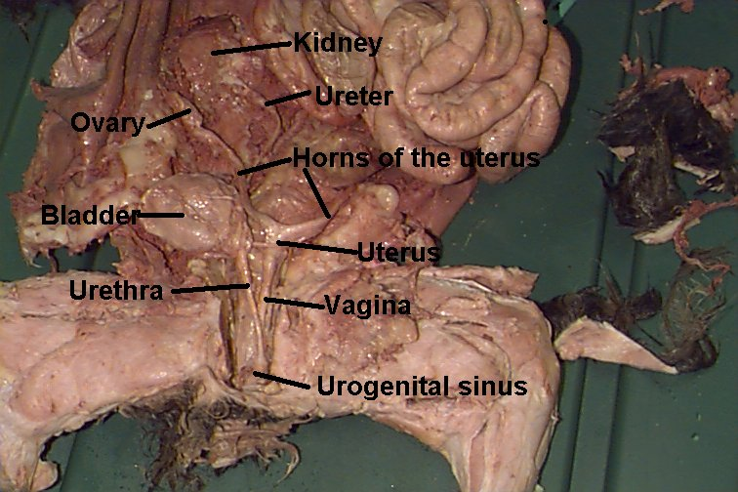](http://www.google.com/url?sa=i&rct=j&q=&esrc=s&frm=1&source=images&cd=&cad=rja&docid=SFxJFQepE-wUDM&tbnid=wgktyVQ9EBSq6M:&ved=0CAUQjRw&url=http://www.rcs.rome.ga.us/hargett/anatomy/cat.htm&ei=1MObUc_YCofrygHqj4HQBw&bvm=bv.46865395,d.aWc&psig=AFQjCNFREwJZQO6p8zmt5UFe41OZH5WJaA&ust=1369249070983621)

**For males**

**(**See photo below**)**

1. Find the **penis** **(color :_______________)**.
2. Locate the **scrotum** **(color :_______________)**. The scrotum is a sac like structure that holds the testes. It may be empty or the testes may still be in it. If you use a blunt probe, you should be able to locate the outside of the scrotum near the anus.
3. Each testicle hangs from the spermatic cord. If the testes are still in the scrotum, carefully open the scrotum and pick at the connective tissue around them until you are able to remove them. They can be removed by gently pulling on the spermatic cord until they are exposed.
4. Once the testes are exposed label the two **spermatic cords** (which contains the vas deferens) **(color :_______________).**
5. Carefully remove the connective tissue around the actual testicle and the epididymis. The **testicle** **(color:_______________)** is the pea-shaped portion and the **epididymis** **(color:_______________)**, is a comma-shaped structure on top of the testicle. Sperm is made in the testis and matures in the epididymis.

[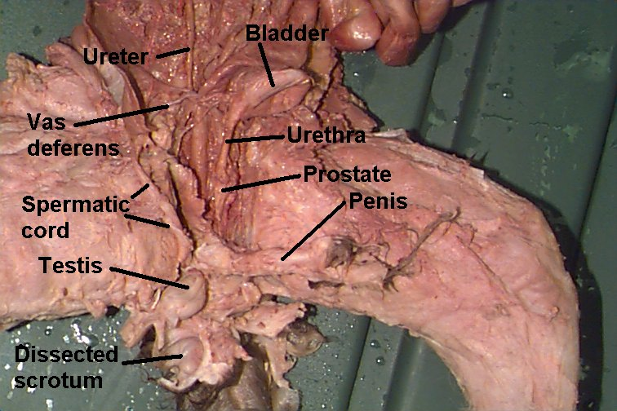](http://www.google.com/url?sa=i&rct=j&q=&esrc=s&frm=1&source=images&cd=&cad=rja&docid=SFxJFQepE-wUDM&tbnid=sFv8Rmy83av8CM:&ved=0CAUQjRw&url=http://www.rcs.rome.ga.us/hargett/anatomy/cat.htm&ei=TcSbUajyAqaHywHji4HwBQ&bvm=bv.46865395,d.aWc&psig=AFQjCNFREwJZQO6p8zmt5UFe41OZH5WJaA&ust=1369249070983621)