**Name:__________________________________**

**Estimating Population Sizes Using Random Sampling**

**Introduction:**

Scientists cannot possibly count every organism in a population. One way to estimate the size of a population is to collect data by taking random samples. In this activity, you will look at how data obtained from random sampling compare with data obtained by an actual count.

**Objective:**

* You will be expected to estimate the size of a sample population using the random sampling technique.
* Be able to apply the technique to new population problems.

**Technique 1 – Random Sampling**

A technique called random sampling is sometimes used to estimate population size. In this procedure, the organisms in a few small areas are counted and projected to the entire area. For instance, if a biologist counts 10 squirrels living in a 200 square foot area, she could predict that there are 100 squirrels living in a 2000 square foot area.

**Procedure:**

The grid shown represents a meadow measuring 10 m on each side. Each grid segment is 1m x 1m. Each black circle represents one sunflower plant.

1. Tear a sheet of paper into 20 slips.
2. Number 10 of the slips from 1 to 10 and put them in a small container.
3. Label the remaining 10 slips from A through J and put them in a second container.
4. Randomly remove one slip from each container.
5. Write down the number-letter combination and find the grid segment that matches the combination.
6. Count the number of sunflower plants in that grid segment. Record this number on the data table.
7. **Return each slip to its appropriate container**.
8. Repeat step 4 until you have data for 10 different grid segments (and the table is filled out).

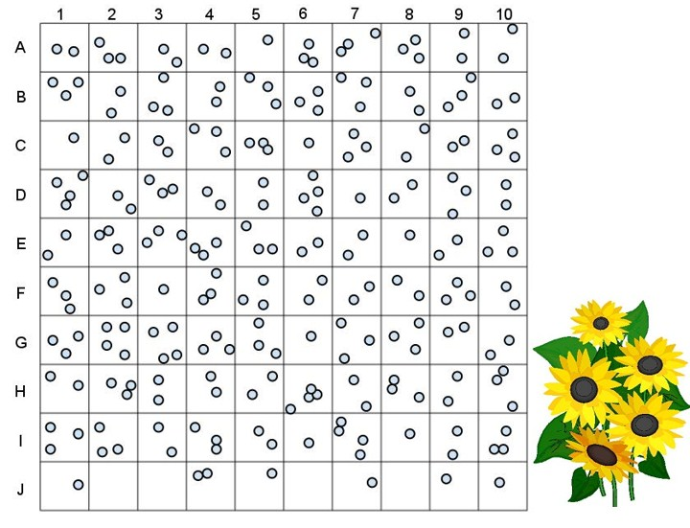

|  |  |  |  |
| --- | --- | --- | --- |
| **Random Sampling Data** | |  | **Actual Data** |
| **Grid Segment  (number - letter)** | **Number of Sunflowers** | **Total number of Sunflowers ______  (count by hand)**  **Average number of Sunflowers  (divide total by 100) Per grid _____**  Description: sunflower |
|  |  |
|  |  |
|  |  |
|  |  |
|  |  |
|  |  |
|  |  |
|  |  |
|  |  |
|  |  |
| **Total Number of Sunflowers** |  |
| **Average (divide total by 10)** |  |
| **Total number of plants in meadow (multiply average by 100)** |  |

1. Compare the total number you got for the sunflowers from using the sampling method to the actual count. How close are they?
2. Why did we divide by 10?
3. Why did we multiply the average number in the boxes we counted by 100?
4. Why would a biologist use sampling?
5. Sampling works best when a population is dispersed randomly or uniformly. Why would sampling not work for populations that are clumped?