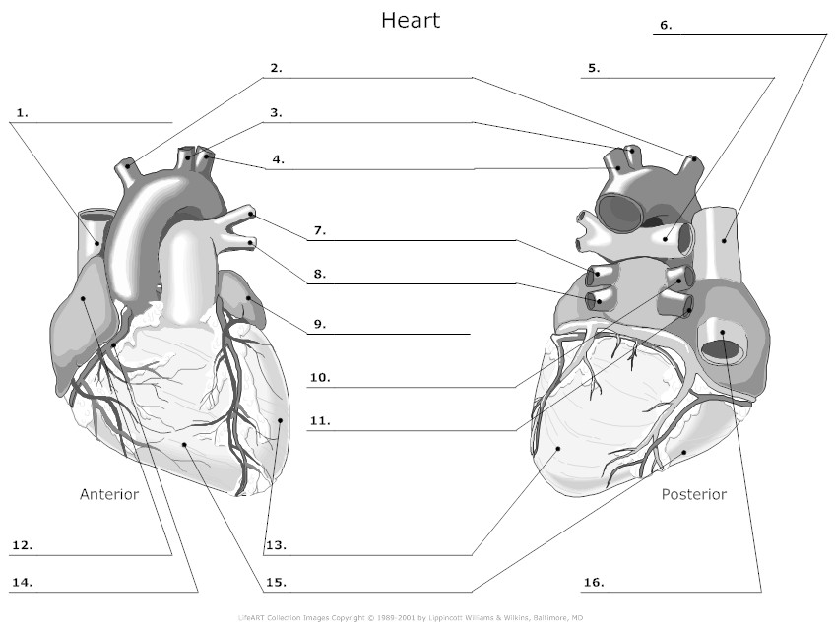

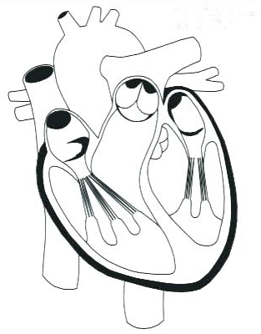
Use Blue Arrows to show the direction of deoxygenated blood in and out of the heart.

Use Red Arrows to show the direction of oxygenated blood in and out of the heart.

Label:
- Right Atrium
- Left Atrium
- Right Ventricle
- Left Ventricle
- Tricuspid
- Bicuspid (Mitral)
- Aortic Semilunar
- Pulmonary Semilunar
- Superior Vena Cava
- Posterior Vena Cava
- Right Pulmonary Arteries
- Left Pulmonary Arteries
- Right Pulmonary Veins
- Left Pulmonary Veins
- Papillary Muscle
- Chordae Tendineae
- Pulmonary Trunk
- Ascending Aorta
- Descending Aorta
- Aortic Arch

Internal

