Circle the term that does not belong in each of the groups below and give a reason for your choice.

Identify the Body Markings
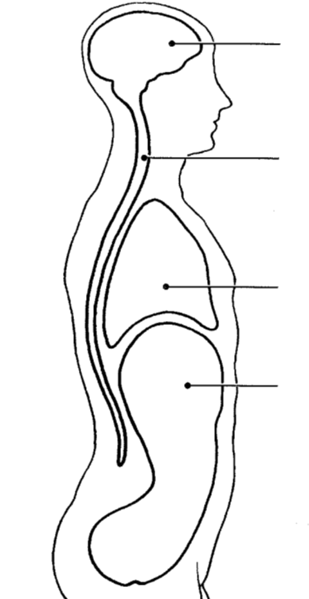
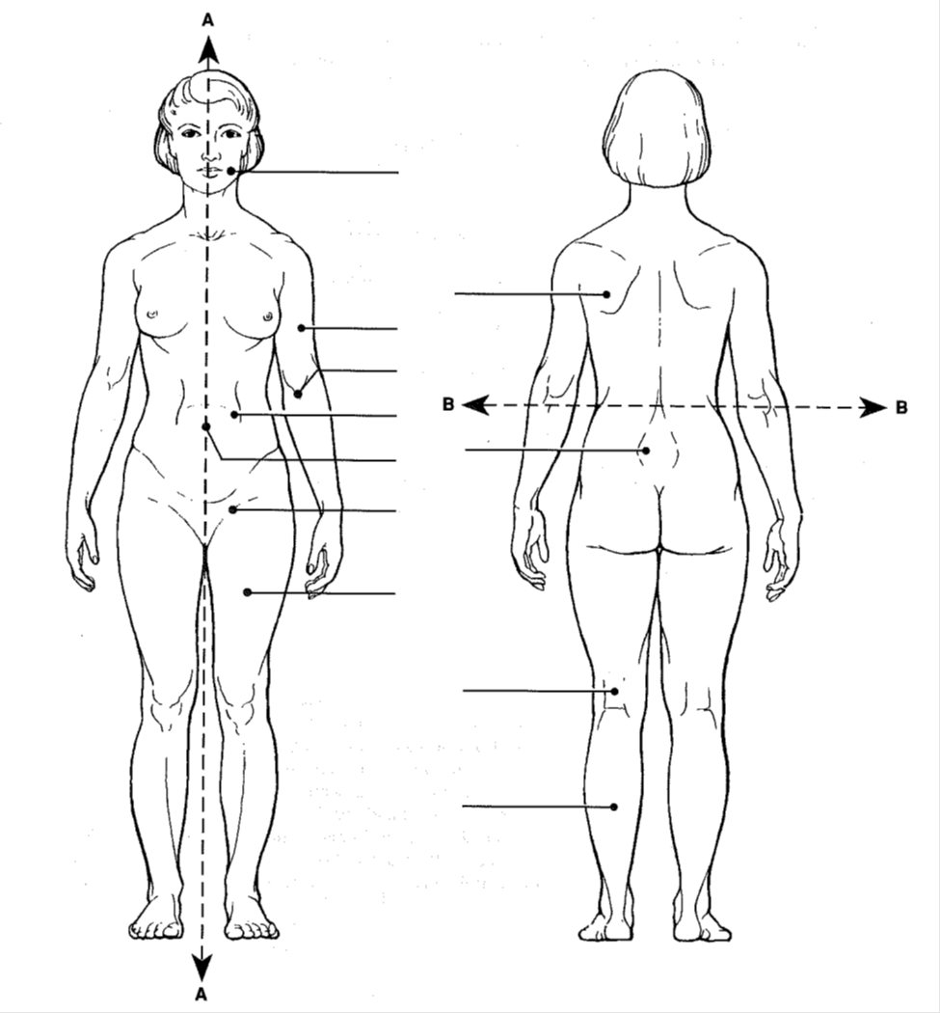
Identify the Body Cavities

