**Name:______________________________**

**Class Notes Date: ________________**

**Text 3.1 p65-67**

|  |  |  |
| --- | --- | --- |
| **Main Ideas** | **Details** | **Your words** |
| ***Studying Our Living Planet*** | | |
| **Biosphere** |  | **Name 2 things from your life that are interdependent.**  **Name something in your life that is dynamic.**  **How are human economics and ecology linked?** |
| **Ecology** |  |
| **Interdependence** |  |
| **Dynamic** |  |
| **Economics** |  |
| ***Figure 3.1 Levels of Organization*** | | |
| **Species** |  |  |
| **Population** |  |
| **Community** |  |
| **Ecosystem** |  |
| **Biome** |  |
| **Label the levels**  **of organization on**  **the diagram.** | | |
| ***Biotic and Abiotic Factors*** | | |
| **Bio- means** |  | |
| **Biology** |  | |
| **Environment** |  | |
| **Biotic** |  | **How are abiotic and biotic factors related to the environment?** |
| **Abiotic** |  |

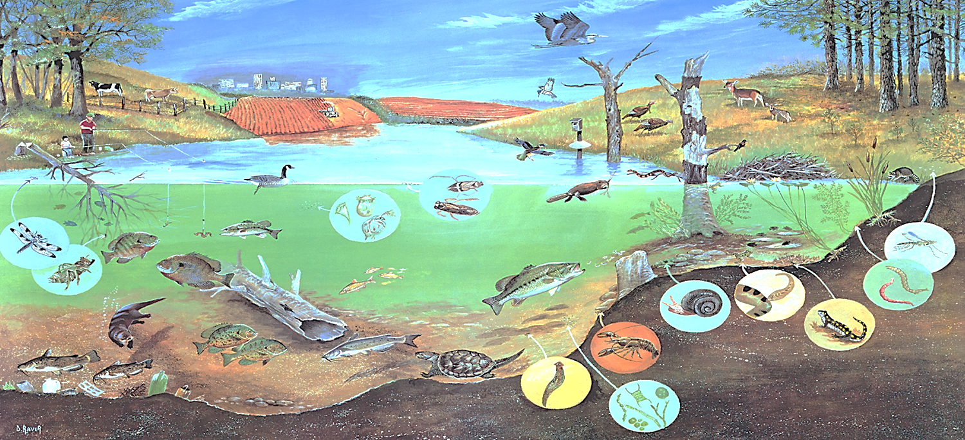

**Use the picture above to name as many factors as you can. If the picture is unclear, try your best to guess what is being shown.**

|  |  |
| --- | --- |
| Abiotic Factors  (at least 6) |  |
| Biotic Factors  (at least 6) |  |