**Name:______________________________**

**Class Notes Date: ________________**

**Text 3.1 p65-67**

|  |  |  |
| --- | --- | --- |
| **Main Ideas** | **Details** | **Your words** |
| ***Studying Our Living Planet*** | | |
| **Biosphere** | **Parts of the earth where life exists** | **Name 2 things from your life that are interdependent.**  **Name something in your life that is dynamic.**  **How are human economics and ecology linked?** |
| **Ecology** | **Interactions between living things and their environment** |
| **Interdependence** | **Relationship between 2 things that depend on each other** |
| **Dynamic** | **ever-changing** |
| **Economics** | **Goods and services for money** |
| ***Figure 3.1 Levels of Organization*** | | |
| **Species** | **Group of similar organisms that can produce fertile offspring** |  |
| **Population** | **Group of the same species in the same area**  **Ex.** All of the coyotes living in Oswego, Illinois in the fall of 2019 |
| **Community** | **Different populations in a specific area**  **Ex.** All of the coyotes, rabbits, squirrels, spiders and dandelions living in Oswego, IL in the fall of 2019 |
| **Ecosystem** | **All the organisms and their environment living together**  **Ex.** All of the coyotes, rabbits, squirrels, spiders dandelions plus the temperature, amount of sunlight, oxygen levels and rainfall. |
| **Biome** | **Group of ecosystems with similar features**  **Ex. Rainforests (similar amount of sunlight, rainfall, plants and animals no matter where they are found)** |
| **biosphere**  **Label the levels**  **of organization on biome**  **the diagram.**  **ecosystem**  **population**  **species**    **community** | | |
| ***Biotic and Abiotic Factors*** | | |
| **Bio- means** | **life** | |
| **Biology** | **Study of life** | |
| **Environment** | **All of the factors and conditions surrounding living things**  **Ex. Mountains, climate, soil types, clouds, oxygen levels** | |
| **Biotic** | **Living things** | **How are abiotic and biotic factors related to the environment?** |
| **Abiotic** | **Nonliving things** |

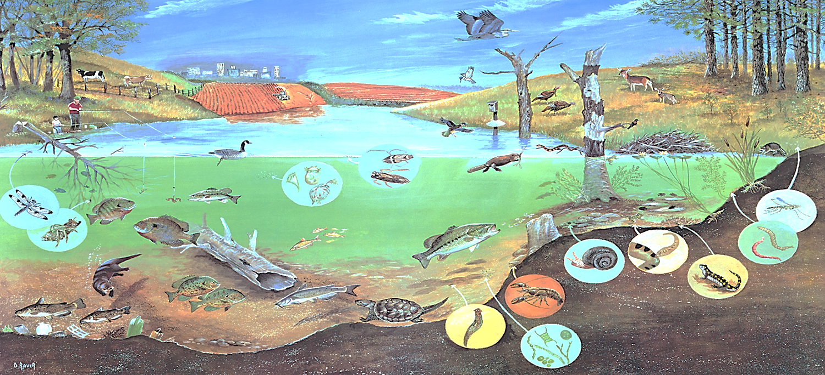

**Use the picture above to name as many factors as you can. If the picture is unclear, try your best to guess what is being shown.**

|  |  |
| --- | --- |
| Abiotic Factors  (at least 6) | Water, soil, air, rocks, sand, pollution from factories or city in background, fertilizer from farm, garbage on the bottom of the pond, bird houses, fishing pole, water temperature, air temperature, amount of oxygen in the water, clouds, light |
| Biotic Factors  (at least 6) | Fish, trees, crops, people, deer, birds, crayfish, frogs, salamander, snail, unicellular pond animals, cow, insects |