**Name:______________________________ Date: ________________**

**Class Notes Text 4.1 p 96**

|  |  |  |  |  |
| --- | --- | --- | --- | --- |
| **Main Ideas** | **Details** | |  | |
| ***Weather and Climate*** | | | | |
| Weather |  | | | |
| Climate |  | | | |
| How would you describe the weather and climate of Oswego, Illinois? | | | | |
| **Factors that Affect Climate** | | | | |
| ***Solar Energy and The Greenhouse Effect*** | | | | |
| Solar Energy (sunlight) that reaches the earth can be: |  | | | **Drawing** |
|  | | | **Drawing** |
| Explain: Why does the inside of a person’s car get so hot in the summer? | | | | |
| Three gases control the amount of heat kept in the atmosphere: | |  | **These gases are called:** | |
|  |
|  |
| Greenhouse Effect: | | <https://www.youtube.com/watch?v=3JX-ioSmNW8&list=PL38EB9C0BC54A9EE2&index=3>  What would happen if the earth did not have greenhouse gases?  How are greenhouse gases like a blanket on the earth?  What happens to the earth if greenhouse gases increase? | | |

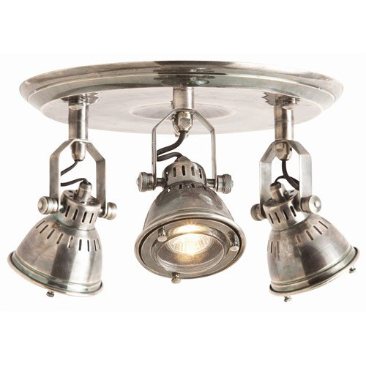**This is the experiment we will be setting up. Answer the questions below before we begin.**



**\*\*Draw arrows from EACH light (similar to what we drew in the notes) to show what you expect the light to do when it reaches EACH jar.**

**Experimenting with jars A and B:**

1. **What is the independent variable?**
2. **What is the dependent variable?**
3. **What do you expect the difference to be between the temperatures of the two jars?**
4. **Explain why you think this will happen?**

**Experimenting with jars B and C:**

**1. What is the independent variable?**

**2. What is the dependent variable?**

**3. What do you expect the difference to be between the**

**temperatures of the two jars?**

**4. Explain why you think this will happen?**