Name: ____________________________________ Period: ________

Population Ecology Graph Worksheet
Graphs 1 Directions: Look at the graphs below and answer the following questions.
A
B

1. Which of the two curves exhibits exponential growth? _________________

2. Which of the two curves exhibits logistic growth? _________________

3. Which of the two curves is most likely to occur under natural conditions?____________________

4. What is the carrying capacity of this graph? ___________________

5. In what generation does the green population reach its carrying capacity? _______________

6. Which population curve would only occur under ideal (perfect) conditions? ______________

7. What do we call factors that stop a population from growing out of control? __________________

8. During which years did graph B show exponential growth? ____________________________

Graph 2 - Competition Curve
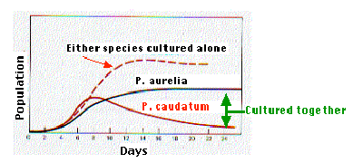
Notice that this graph shows the growth of 2 species of bacteria grown together. It also shows their growth rate when grown separately.

9. Compare the growth rate for P. caudatum
Either species grown alone
when it is grown alone and when it is
grown with P. aurelia?

________________________________

________________________________
Grown together

________________________________

10. What happens to the growth rate of P. aurelia around
day 12?

___________________________________________________________________________________

11. Explain why P. caudatum’s population is dropping on days 10-24.

___________________________________________________________________________________

Graph 3
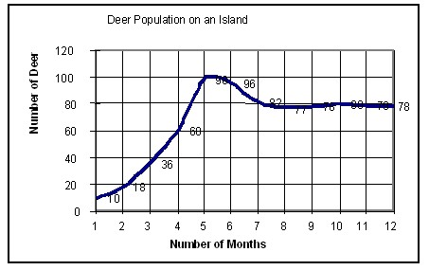

12. During which months was the growth of the deer population exponential?_______________________

13. Give one possible reason why the population decreased after 5 months

___________________________________________________________________________

14. What is the approximate carrying capacity of the island? ___________________________

15. Explain carrying capacity? ___________________________________________________________

16. What type of density dependent factors may cause the population to decrease (name 2)?

___________________________________________________________________________________

17. What type of density independent factors may cause the population to decrease (name 2)?

___________________________________________________________________________________

18. Overall, do deer populations seem to exhibit exponential or logistic growth? Explain why.______________

___________________________________________________________________________________

