AP Human Geography Name _______________________________

Vacation FRQ

A B

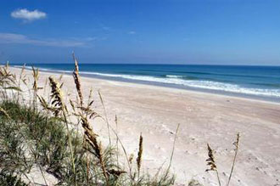 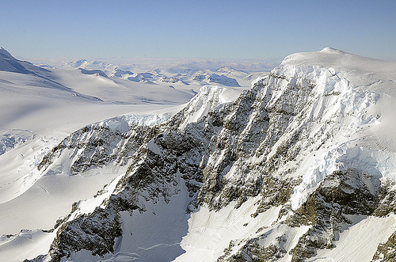

Source: NASA.gov

1. Summer is a time when many people travel away from home. They must decide which type of location to spend their time away from home.

a. Define the term vacation.

1. Identify physical feature A above and list 2 activities a person could do there.
2. Identify physical feature B above and list 2 activities a person could do there.
3. Describe which location would most likely be visited by a family with small children.

Use the ABCD’s of Writing the FRQ to prepare this prompt to be answered:

* Attack the prompt
* Brainstorm possible answers
* Choose the order of your responses
* Detect errors before turning in

When writing your answer:

1. Set up your answer in the same format as the question
2. Label all parts
3. Use complete sentences, not bullets.
4. Write legibly in ink

____________________________________________________________________________________________________________________________________________________________________________________________________________________________________________________________________________________________________________________________________________________________________________________________________________________________________________________________________________________

____________________________________________________________________________________________________________________________________________________________________________________________________________________________________________________________________________________________________________________________________________________________________________________________________________________________________________________________________________________

____________________________________________________________________________________________________________________________________________________________________________________________________________________________________________________________________________________________________________________________________________________________________________________________________________________________________________________________________________________

____________________________________________________________________________________________________________________________________________________________________________________________________________________________________________________________________________________________________________________________________________________________________________________________________________________________________________________________________________________

____________________________________________________________________________________________________________________________________________________________________________________________________________________________________________________________________________________________________________________________________________________________________________________________________________________________________________________________________________________

____________________________________________________________________________________________________________________________________________________________________________________________________________________________________________________________________________________________________________________________________________________________________________________________________________________________________________________________________________________

__________________________________________________________________________________________________________________________________________________________________________________________________________________________________________